


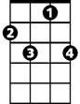



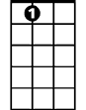

Me And Bobby McGee (Kris Kristofferson & Fred Foster, 1969) (C)

C G7
Busted flat in Baton Rouge, heading for the trains, feelin' nearly faded as my jeans
C
Bobby thumbed a diesel down, just before it rained. Took us all the way into New Orleans
C C7 F
I pulled my harpoon out of my dirty red bandana and was blowin’ sad while Bobby sang the blues.
With them windshield wipers slappin' time,
C G C - C7
and Bobby clappin’ hands, we finally sang up every song that driver knew

F C G7 C C7
_ Freedom's just another word for _ nothin' left to lose. _ Nothin' ain't worth nothin', but it’s free
F C
_ Feelin' good was easy, Lord, when _ Bobby sang the blues
G7 C - C# D
You know _ feelin' good was good enough for me. Good enough for me and my Bobby McGee.

D A7
From the coal mines of Kentucky to the California sun Bobby shared the secrets of my soul.
D
Standing right beside me through everythin’ I done and every night she kept me from the cold.
D
Then somewhere near Salinas, Lord, I let her slip away.
D7 G
She was lookin' for the home I hope she’ll find.
D A7 D D7
Well I'd trade all my tomorrows for a single yesterday, holdin' Bobby's body close to mine.

Outro (2X)
G D A7 D D7
_ Freedom's just another word for _ nothin' left to lose. _ Nothin' ain't worth nothin', but it’s free
G D
_ Feelin' good was easy, Lord, when _ Bobby sang the blues.
A7
You know _ feelin' good was good enough for me.
D | A7 D |
Good enough for me and my Bobby McGee.

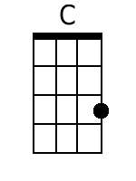 | 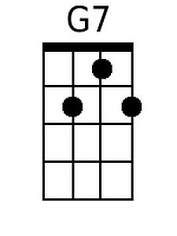 | 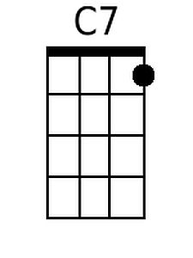 | 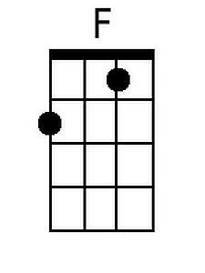 | 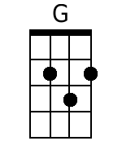 | 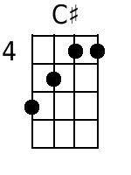 | 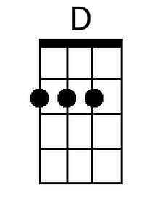 | 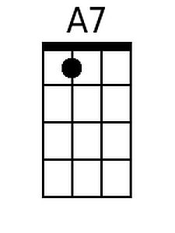 | 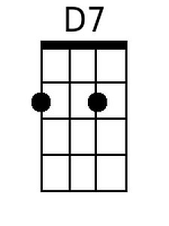
Bari
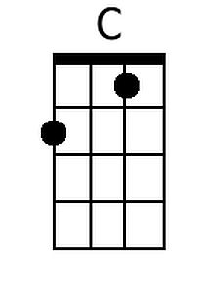 | 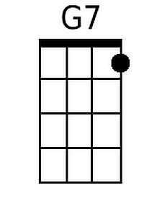 | 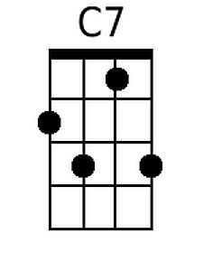 | 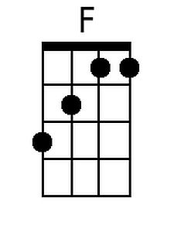 | 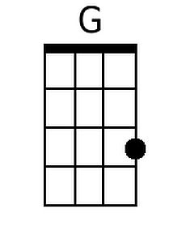 | 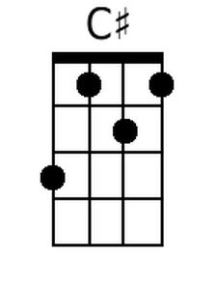 | 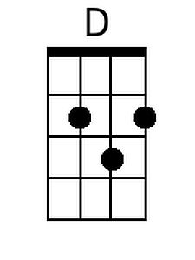 | 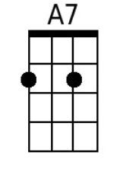 | 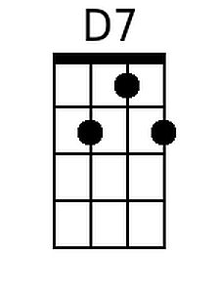

Me And Bobby McGee (Kris Kristofferson & Fred Foster, 1969) (G)

G D7
Busted flat in Baton Rouge, heading for the trains, feelin' nearly faded as my jeans
G
Bobby thumbed a diesel down, just before it rained. Took us all the way into New Orleans
G G7 C
I pulled my harpoon out of my dirty red bandana and was blowin' sad while Bobby sang the blues.
With them windshield wipers slappin' time,
G D G - G7
and Bobby clappin' hands, we finally sang up every song that driver knew.

C G D7 G G7
_ Freedom's just another word for _ nothin' left to lose. _ Nothin' ain't worth nothin', but it's free
C G
_ Feelin' good was easy, Lord, when _ Bobby sang the blues
D7 G - G# A
You know __ feelin' good was good enough for me. Good enough for me and my Bobby McGee.

A E7
From the coal mines of Kentucky to the California sun Bobby shared the secrets of my soul.
A
Standing right beside me through everythin' I done and every night she kept me from the cold.
A
Then somewhere near Salinas, Lord, I let her slip away.
A7 D
She was lookin' for the home I hope she'll find.
A E7 A A7
Well I'd trade all my tomorrows for a single yesterday, holdin' Bobby's body close to mine.

Outro (2X)
D A E7 A A7
_ Freedom's just another word for _ nothin' left to lose. _ Nothin' ain't worth nothin', but it's free.
D A
_ Feelin' good was easy, Lord, when _ Bobby sang the blues.
E7 A
You know __ feelin' good was good enough for me.
A | E7 A |
Good enough for me and my Bobby McGee.

 |  |  |  |  | 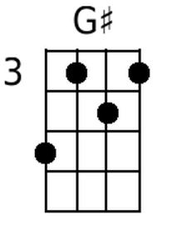 | 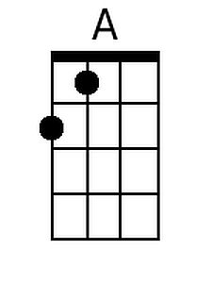 | 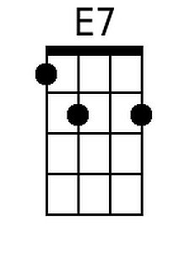
Bari
 |  |  |  |  | 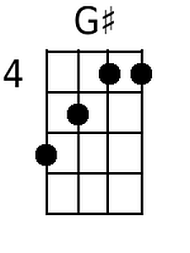 | 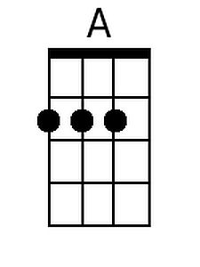 | 