Mele Kalikimaka (R. Alex Anderson)
C14 C
Key C – Starting Note: G

C
Mele Kalikimaka is the thing to say
G
On a bright Hawaiian Christmas Day
G7
That's the island greeting that we send to you
Dm C
From the land where palm trees sway
C7 F
Here we know that Christmas will be green and bright
A7 D7 G7
The sun will shine by day and all the stars by night
C C7 A7
Mele Kalikimaka is Hawaii's way
Dm G7 C
To say Merry Christmas to you

(Repeat entire song; replace last line with ending)

Dm G7 Dm G7
To say Merry Christmas, a very Merry Christmas
Dm G7 C
To say Merry Christmas to you


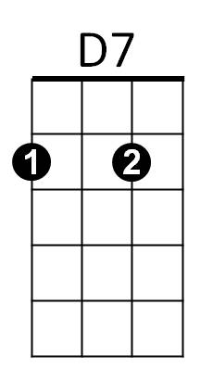
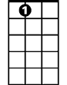




G
Dm
A7
F
C7
C
G7

BARITONE
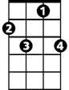


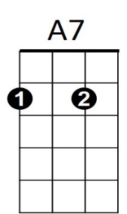
G
C7
F
C
G7
D7
Dm

Mele Kalikimaka (R. Alex Anderson)
C14 G
Key G - Starting Note: D

G
Mele Kalikimaka is the thing to say
D
On a bright Hawaiian Christmas Day
D7
That's the island greeting that we send to you
Am G
From the land where palm trees sway
G7 C
Here we know that Christmas will be green and bright
E7 A7 D7
The sun will shine by day and all the stars by night
G G7 E7
Mele Kalikimaka is Hawaii's way
Am D7 G
To say Merry Christmas to you

(Repeat entire song; replace last line with ending)

Am D7 Am D7
To say Merry Christmas, a very Merry Christmas
Am D7 G
To say Merry Christmas to you
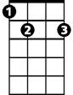


G
C
E7
G7
Am
A7
D

BARITONE
D
C
E7
Am
D7
G7
G

