Mister Sandman (Pat Ballard)

C7 F E7
Mister Sandman, bring me a dream
A7 D7
Make him the cutest that I've ever seen
G7 C7
Give him two lips like roses and clover
F C#7 C7
Then tell him that his lonesome nights are over

C7 F E7
Mister Sandman, I'm so alone
A7 D7
Don't have nobody to call my own
Gm7 Gm7-5
Please turn on your magic beam
F G7 F C7
Mister Sandman, bring me a dream

C7 F E7
Mister Sandman, bring me a dream
A7 D7
Make him the cutest that I've ever seen
G7 C7
Give him the word that I'm not a rover
F C#7 C7
Then tell him that his lonesome nights are over

C7 F E7

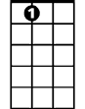
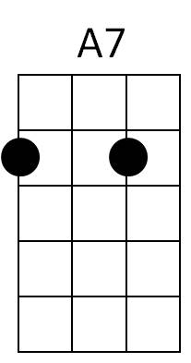
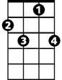


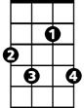
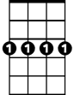
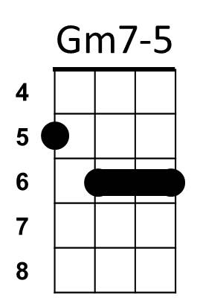
Mister Sandman, I'm so alone
BARITONE
F
E7
C7
D7
G7
C#7
Gm7
A7 D7
Don't have nobody to call my own
Gm7 Gm7-5
Please turn on your magic beam
F G7 F C7
Mister Sandman, bring me a dream

C7 F E7
Mister Sandman, yes bring us a dream
A7 D7
Give him a pair of eyes with a "come-hither" gleam
G7 C7
Give him a lonely heart like Pagliacci
F C#7 C7
And lots of wavy hair like Liberace

C7 F E7
Mister Sandman, someone to hold
A7 D7
Would be so peachy before we're too old
Gm7 Gm7-5
Please turn on your magic beam
F G7
Mister Sandman,bring us,
F G7
Please, please, bring us,
F G7 F
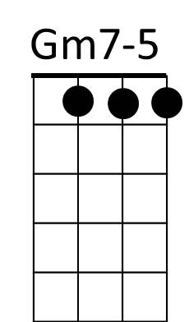
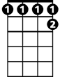
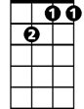
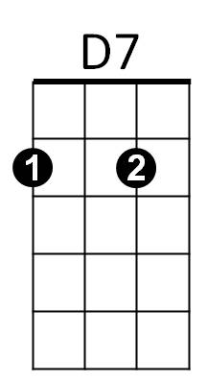

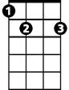
Mister Sandman, bring us a dream
C#7
G7
Gm7
A7
F
C7
E7

