Mr. Tambourine Man (Bob Dylan) Key of G

INTRO G D / G D 2x
G
CHORUS:
C D G C
Hey! Mr. Tambourine Man, play a song for me,

G C D Dsus2 D Dsus2
D
I'm not sleepy and there ain't no place I'm goin' to.
C D G C
Hey! Mr. Tambourine Man, play a song for me,
G C D G Gsus4 G Gsus4
In the jingle jangle morning, I'll come followin' you.
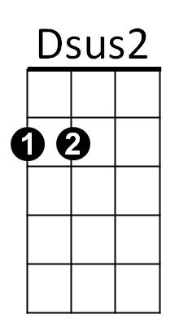
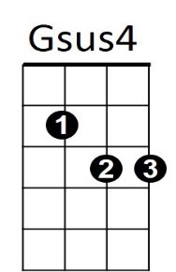

C
C D G C
Take me for a trip upon your magic swirlin' ship,
G C
All my senses have been stripped,
G C
And my hands can't feel to grip.
G C
And my toes too numb to step,
BARITONE
D
G
G C D
Wait only for my boot heels, to be wanderin'.

C D G C
I'm ready to go anywhere, I'm ready for to fade,
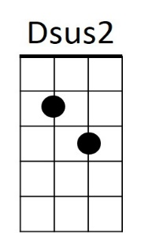

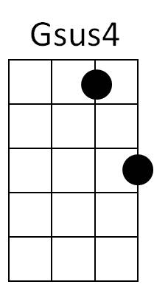
G C
C
On to my own parade.
G C
Cast your dancin' spell my way,
D
I promise to go under it.

(CHORUS)

C D G C
Hey! Mr. Tambourine Man, play a song for me,
G C D Dsus2 D Dsus2
I'm not sleepy and there ain't no place I'm goin' to.
C D G C
Hey! Mr. Tambourine Man, play a song for me,
G C D G (Outro) - G D / G D (2x) end in G
In the jingle jangle morning, I'll come followin' you.
Mr. Tambourine Man (Bob Dylan) Key of D
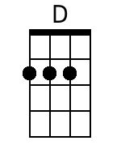
INTRO D A / D A (2x)
CHORUS:
G A D G
Hey! Mr. Tambourine Man, play a song for me,
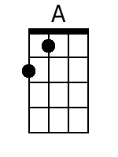
D G A Asus4 A Asus4
I'm not sleepy and there ain't no place I'm goin' to.
G A D G
Hey! Mr. Tambourine Man, play a song for me,
D G A D Dsus2 D Dsus2
In the jingle jangle morning, I'll come followin' you.
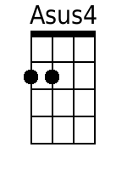
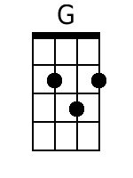
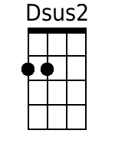
G A D G
Take me for a trip upon your magic swirlin' ship,
D G
All my senses have been stripped,
D G
And my hands can't feel to grip.
D G
BARITONE
And my toes too numb to step,
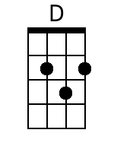
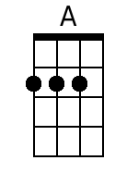
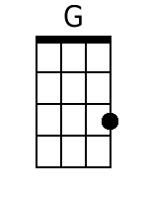
D G A
Wait only for my boot heels, to be wanderin'.

G A D G
I'm ready to go anywhere, I'm ready for to fade,
D G
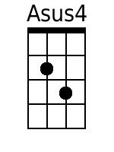
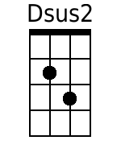
On to my own parade.
D G
Cast your dancin' spell my way,
A
I promise to go under it.

(CHORUS)

G A D G
Hey! Mr. Tambourine Man, play a song for me,
D G A Asus4 A Asus4
I'm not sleepy and there ain't no place I'm goin' to.
G A D G
Hey! Mr. Tambourine Man, play a song for me,
D G A D (Outro) D A / D A (2x) End in D
In the jingle jangle morning, I'll come followin' you.

Mr. Tambourine Man (Bob Dylan) Key of C
INTRO C G / C G (2x)
CHORUS:
F G C F
Hey! Mr. Tambourine Man, play a song for me,
C F G Gsus4 G Gsus4
I'm not sleepy and there ain't no place I'm goin' to.
F G C F
Hey! Mr. Tambourine Man, play a song for me,
C F G C Csus2 C Csus2
In the jingle jangle morning, I'll come followin' you.
F G C F
Take me for a trip upon your magic swirlin' ship,
C F
All my senses have been stripped,
C F
And my hands can't feel to grip.
C F
BARITONE
And my toes too numb to step,
C F G
Wait only for my boot heels, to be wanderin'.

F G C F
I'm ready to go anywhere, I'm ready for to fade,
C F
On to my own parade.
C F
Cast your dancin' spell my way,
G
I promise to go under it.

(CHORUS)

F G C F
Hey! Mr. Tambourine Man, play a song for me,
C F G Gsus4 G Gsus4
I'm not sleepy and there ain't no place I'm goin' to.
F G C F
Hey! Mr. Tambourine Man, play a song for me,
C F G C (Outro) C G / C G (2x) End in C
In the jingle jangle morning, I'll come followin' you.

