Moon River (Johnny Mercer / Henry Mancini) Key C



Intro: C Am F G
C
Am
F

C Am F C
Moon River, wider than a mile
F C Dm E7

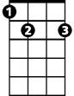

I'm crossing you in style some day
G
E7
Dm
Am Em F Em
Oh, dream maker, you heart breaker
Am D Em F G
Wherever you're goin', I'm goin' your way

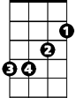
D
Em
C Am F C
Two drifters, off to see the world
F C Dm E7
There's such a lot of world to see
Am Em Am F C
We're af - ter the same rainbow's end,
F C F C
Waitin' 'round the bend, my Huckleberry friend,
Am F G C
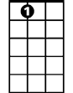


Moon River, and me
E7
Em
D
Dm
F
G
Am
C
BARITONE
C Am F G
(Repeat entire song)

C Am (3X) End C
Moon River

Moon River (Johnny Mercer / Henry Mancini) Key G
Intro: G Em C D
G
Em
C

G Em C G
Moon River, wider than a mile
C G Am B7
Am
D
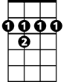
I'm crossing you in style some day
B7
Em Bm C Bm
Oh, dream maker, you heart breaker
Em A Bm C D
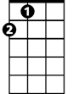
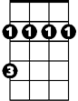
Wherever you're goin', I'm goin' your way
A
Bm

G Em C G
Two drifters, off to see the world
C G Am B7
There's such a lot of world to see
Em Bm Em C G
We're af - ter the same rainbow's end,
C G C G
Waitin' 'round the bend, my Huckleberry friend,
Em C D G
Moon River, and me
G Em C D
BARITONE
A
Bm
B7
Am
G
Em
C
D
(Repeat entire song)

G Em (3X) End G
Moon River

Moon River (Johnny Mercer / Henry Mancini) Key F
Intro: F Dm Bb C
Bb
Dm
F

F Dm Bb F
Moon River, wider than a mile
Bb F Gm A7
I'm crossing you in style some day
A7
Gm
C
Dm Am Bb Am
Oh, dream maker, you heart breaker
Dm G Am Bb C
Wherever you're goin', I'm goin' your way
G
Am
F Dm Bb F
Two drifters, off to see the world
Bb F Gm A7
There's such a lot of world to see
Dm Am Dm Bb F
We're af - ter the same rainbow's end,
Bb F Bb F
Waitin' 'round the bend, my Huckleberry friend,
Dm Bb C F
Moon River, and me
F Dm Bb C
BARITONE
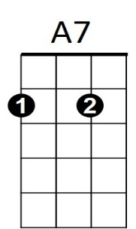
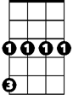
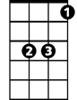
G
Am
Gm
C
Bb
Dm
F
(Repeat entire song)

F Dm (3X) And F
Moon River

