Moondance (Van Morrison)

INTRO: Dm Em7 Dm Em7 (two times)
Dm Em7 Dm Em7 Dm Em7 Dm Em7
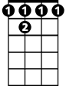

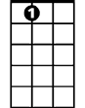

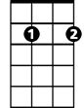

Well it's a marvelous night for a moondance with the stars up above in your eyes
Bb7
C7
A7
Gm
Em7
Dm
Dm Em7 Dm Em7 Dm Em7 Dm Em7
A fantabulous night to make romance 'neath the color of October skies
Dm Em7 Dm Em7 Dm Em7 Dm Em7
All th e leaves on the trees are falling to the sounds of the breezes that blow
Dm Em7 Dm Em7 Dm Em7 Dm
And I’m trying to place to the calling of your heartstrings that play soft and low
Gm Dm Gm Dm
You know the ni-ght's magic seems to - whisper and hush
Gm Dm Gm A7
You know the so-ft moonlight seems to shine in your blush

CHORUS:

Dm Gm Dm Gm Dm Gm Dm Gm
Can I just have one more moondance with you........my love
Dm Gm Dm Gm Dm Gm Dm A7
Can I just have one more moondance with you........my love

Dm Em7 Dm Em7 Dm Em7 Dm Em7
Well I want to make love to you tonight - I can't wait til the morning has come
Dm Em7 Dm Em7 Dm Em7 Dm Em7
And I know now the time is just right - And straight into my arms you will run
Dm Em7 Dm Em7 Dm Em7 Dm Em7
When you come my heart will be waiting - to make sure that you're never alone
Dm Em7 Dm Em7 Dm Em7 Dm
There and then all my dreams will come true dear there and then I will make you my own
Gm Dm Gm Dm
BARITONE
And everytime I – I touch you, you just, tremble inside
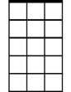
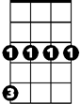
Gm Dm Gm A7
Em7
Dm
Gm
Then I know ho--w much you want me, that you -- can't hide

(CHORUS)

(REPEAT VERSE 1 THRU CHORUS)

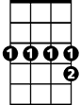
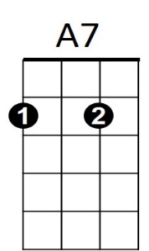
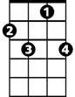
Dm Gm Dm Gm Dm Gm Dm Gm
Bb7
C7
One more moondance with you In the moonlight
Dm Gm Dm Gm Dm Gm Dm Gm
On a magic night La la la la la la la la la la la la la la la
Dm Gm Dm Gm Dm Gm Dm Gm
In the moonlight On a magic night
Dm C7 Bb7 A7 Gm Dm
Can I... just have... one more... moondance with you …..My love

