Moonlight Feels Right (Bruce Blackman)

Em7
The wind blew some luck in my direction
Am Cmaj7
I caught it in my hands today
Em7
I finally made a tricky French connection
Am Cmaj7
You winked and gave me your O.K.
A
I'll take you on a trip beside the ocean
Cmaj7
And drop the top at Chesapeake Bay
A
Ain't nothing like the sky to dose a potion
F G7
The moon’ll send you on your way

Chorus:
Cmaj7 G7
Moonlight - feels right
Cmaj7 G7
Moonlight - feels right

Em7
We'll lay back and observe the constellations
Am Cmaj7
And watch the moon smilin' bright
Em7
I'll play the radio on southern stations
Am Cmaj7
'Cause southern belles are hell at night
A
You say you came to Baltimore from Ole Miss
Cmaj7
A Class of seven-four, gold ring
A
The eastern moon looks ready for a wet kiss
F G7
To make the tide rise again

(Chorus)

Em7
We'll see the sun come up on Sunday morning
Am Cmaj7
And watch it fade the moon away
Em7
I guess you know I'm giving you a warning
Am Cmaj7
'Cause me and moon are itching to play
A
I'll take you on a trip beside the ocean
Cmaj7
And drop the top at Chesapeake Bay
A
Ain't nothin' like the sky to dose a potion
F G7
The moon'll send you on your way

(Chorus) (2x)



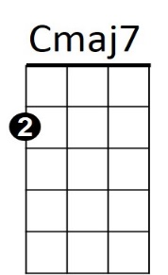

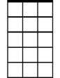


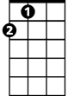

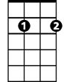
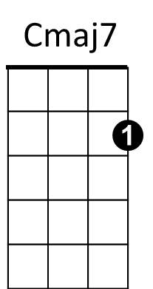
BARITONE
F
G7
A
Am
Em7
F
G7
A
Am
Em7

