More (Riz Ortolani & Nino Oliviero) Key of C
(Theme from Mondo Cane)
C



Dm
Am
C
C Am Dm G7
More than the greatest love the world has known
C Am Dm G7
This is the love I'll give to you alone
C Am Dm G7
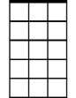
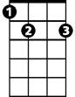

More than the simple words I try to say
Am7
E7
G7
C Am Dm G7
I only live to love you more each day

Am Dm
More than you'll ever know

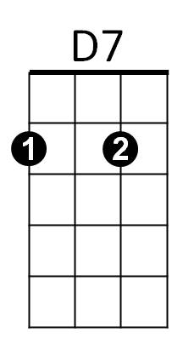
Am Dm
F
My arms long to hold you so
C Dm
My life will be in your keeping
C G7
Wak ing, sleeping, laughing, weeping

C Am Dm G7
Longer than alw ays is a long, long time
C Am Dm E7
BARITONE

But far beyond forever you'll be mine
Dm
Am
C
Am Am7 Am
I know I've never lived before
D7 Dm
And my heart is very sure
G7 C
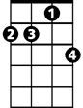
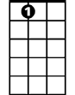

No one else could love you more
Am7
E7
G7

C Am Dm G7
Longer than always is a long, long time
C Am Dm E7
But far beyond forever you'll be mine

Am Am7 Am
D7
F
I know I've never lived before
D7 Dm
And my heart is very sure
G7 C F C
No one else could love you more

More (Riz Ortolani & Nino Oliviero) Key of G
(Theme from Mondo Cane)
G
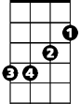

Am
Em
G
G Em Am D7
BARITONE
More than the greatest love the world has known
G Em Am D7
This is the love I'll give to you alone
G Em Am D7
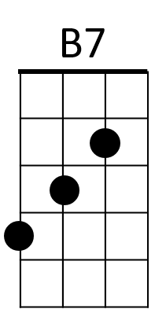
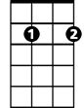
More than the simple words I try to say
Em7
G Em Am D7
I only live to love you more each day

Em Am
More than you'll ever know
Em Am
A7
C
My arms long to hold you so
C Am
My life will be in your keeping
C D7
Waking, sleeping, laughing, weeping

G Em Am D7
Longer than always is a long, long time
G Em Am B7
But far beyond forever you'll be mine
Em Em7 Em
G
Am
Em
I know I've never lived before
A7 Am
And my heart is very sure
D7 G
No one else could love you more
Em7
B7
D7
Em

G Em Am D7
Longer than always is a long, long time
G Em Am B7
But far beyond forever you'll be mine
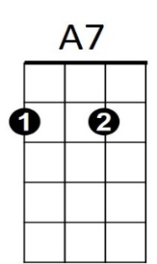
Em Em7 Em
C
I know I've never lived before
A7 Am
And my heart is very sure
D7 G C G
No one else could love you more

