






Mr. Bojangles (Jerry Jeff Walker, ca. 1965) (C) (¾)

Intro: C Em Am F G C  C Em Am F G  I knew a man Bojangles and he danced for you - In worn out shoes  C Em Am F G  With silver hair a ragged shirt and baggy pants - The old soft shoe  F Em Am Dm G  _ He jumped so high, jumped so high - Then he'd lightly touch down.  Chorus  Am G Am G Am G C F C  Mr. Bojangles Mr. Bojangles Mr. Bojangles dance  C Em Am F G  I met him in a cell in New Orleans I was - down and out  C Em Am F G  He looked to me to be - the eyes of age - as he spoke right out  F Em Am Dm G  _ He talked of life, talked of life - He laughed, slapped his leg a step  C Em Am F G  He said his name Bojangles then he danced a licked - across the cell  C Em  He grabbed his pants, a better stance,  Am F G  oh he jumped so high, and he clicked his heels  F Em Am Dm G  _ He let go a laugh, let go a laugh, shook back his clothes all around. Chorus  C Em Am F G  He danced for those at minstrel shows and county fairs - throughout the south.  C Em Am F G  He spoke with tears of 15 years how his dog and him - traveled about  F Em Am Dm G  _ His dog up and died, up and died, after 20 years he still grieves  C Em Am F G  He said I dance now at every chance in honky tonks - for drinks and tips  C Em Am F G  But most the time I spend behind these county bars - cause I drinks a bit  F Em Am  _ He shook his head, and as he shook his head -  Dm G  I heard someone ask him please – please. Chorus |  |  |  |  |  |  | 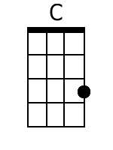
 |  |  |  |  |  |  | 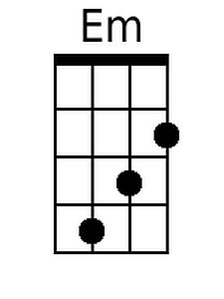
 |  |  |  |  |  |  | 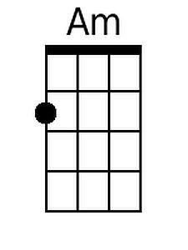
 |  |  |  |  |  |  | 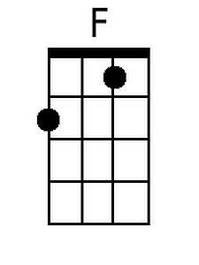
 |  |  |  |  |  |  | 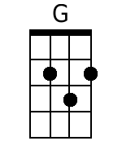
 |  |  |  |  |  |  | 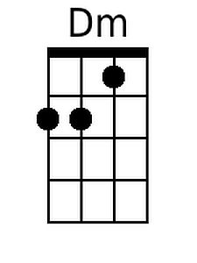
Strum: 1 2&3& | DGBE | 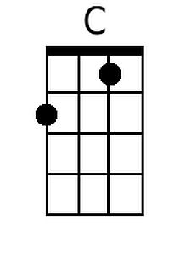 | 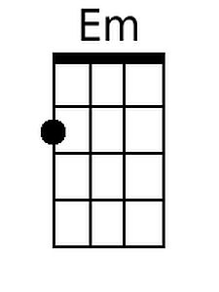 | 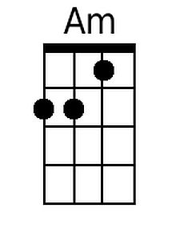 | 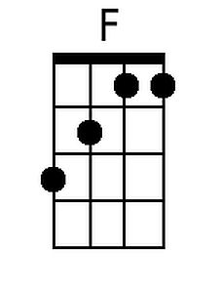 | 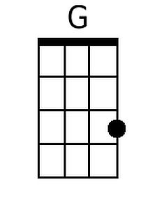 | 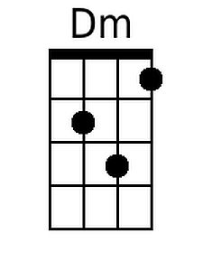

Mr. Bojangles (Jerry Jeff Walker, ca. 1965) (G) (¾)

Intro: G Bm Em C D G

G Bm Em C D
I knew a man Bojangles and he danced for you - In worn out shoes
G Bm Em C D
With silver hair a ragged shirt and baggy pants - The old soft shoe
C Bm Em Am D
_ He jumped so high, jumped so high - Then he'd lightly touch down.

Chorus
Em D Em D Em D G C G
Mr. Bojangles Mr. Bojangles Mr. Bojangles dance

G Bm Em C D
I met him in a cell in New Orleans I was - down and out
G Bm Em C D
He looked to me to be - the eyes of age - as he spoke right out
C Bm Em Am D
_ He talked of life, talked of life - He laughed, slapped his leg a step

G Bm Em C D
He said his name Bojangles then he danced a licked - across the cell
G Bm
He grabbed his pants, a better stance,
Em C D
oh he jumped so high, and he clicked his heels
C Bm Em Am D
_ He let go a laugh, let go a laugh, shook back his clothes all around. Chorus

G Bm Em C D
He danced for those at minstrel shows and county fairs - throughout the south.
G Bm Em C D
He spoke with tears of 15 years how his dog and him - traveled about
C Bm Em Am D
_ His dog up and died, up and died, after 20 years he still grieves

G Bm Em C D
He said I dance now at every chance in honky tonks - for drinks and tips
G Bm Em C D
But most the time I spend behind these county bars - cause I drinks a bit
C Bm Em
_ He shook his head, and as he shook his head -
Am D
I heard someone ask him please – please. Chorus

 |  |  |  |  |  |  | 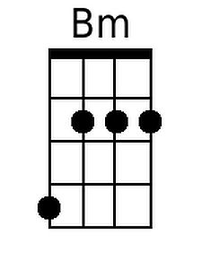
 |  |  |  |  |  |  | 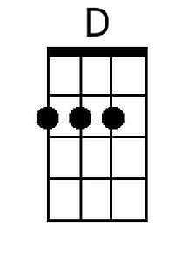
Strum: 1 2&3& | DGBE |  | 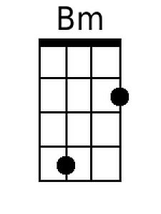 |  |  | 