






Mr. Bojangles (Jerry Jeff Walker, ca. 1965) (C) (6/8 Time)

Intro: C Em | Am Em  C Em Am F G - G7  I knew a man Bo-jangles and he danced for you _ In worn out shoes  C Em Am F G  With silver hair, a ragged shirt, and baggy pants _ The old soft shoe  F Em Am Em Dm (D7) G  _ He jumped so high, jumped so high __ Then he'd lightly touch down.  Chorus  Am G Am G Am G C Em | Am Em  __ Mr. Bo-jangles __ Mr. Bo-jangles __ Mr. Bo-jangles . . . dance.  C Em Am F G - G7  I met him in a cell in New Or-leans I was _ down and out  C Em Am F G  He looked to me to be - the eyes of age _ as he spoke right out  F Em Am Em Dm (D7) G - G7  _ He talked of life, talked of life __ He laughed, slapped his leg a step  C Em Am F G - G7  He said his name Bo-jangles then he danced a licked _ across the cell  C Em  He grabbed his pants, a better stance,  Am F G  oh he jumped so high, _ and he clicked his heels  F Em Am Em Dm (D7) G  _ He let go a laugh, let go a laugh, __ shook back his clothes all a-round. Chorus  C Em Am F G - G7  He danced for those at minstrel shows and county fairs _ throughout the south.  C Em Am F G  He spoke with tears of 15 years how his dog and him _ traveled a-bout  F Em Am Em Dm (D7) G - G7  _ His dog up and died, he up and died, __ after 20 years he still grieves.  C Em Am F G - G7  He said I dance now at every chance in honky tonks _ for drinks and tips  C Em Am F G  But most the time I spend behind these county bars _ ‘cause I drinks a bit  F Em Am Em  _ He shook his head, and as he shook his head,  Dm (D7) G  __ I heard someone ask him please – please. Chorus. End on C. |  |  |  |  |  |  |  | 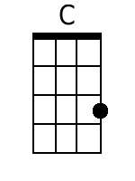
 |  |  |  |  |  |  |  | 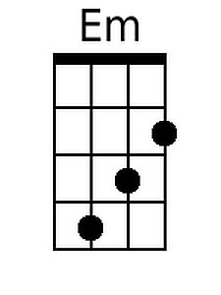
 |  |  |  |  |  |  |  | 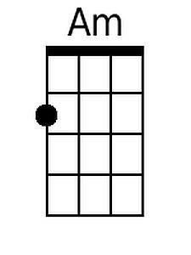
 |  |  |  |  |  |  |  | 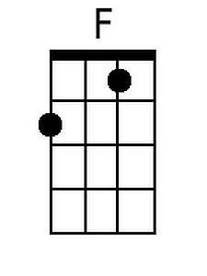
 |  |  |  |  |  |  |  | 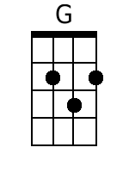
 |  |  |  |  |  |  |  | 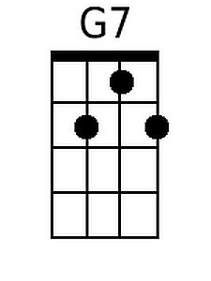
 |  |  |  |  |  |  |  | 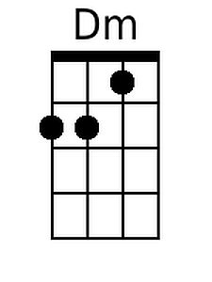
 |  |  |  |  |  |  |  | 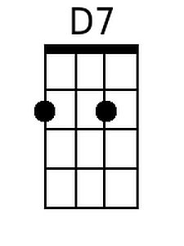
DGBE | 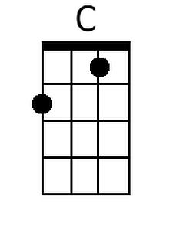 | 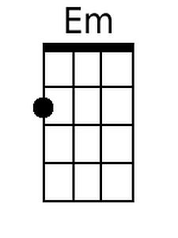 | 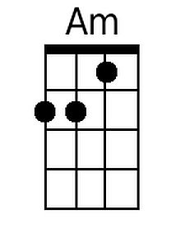 | 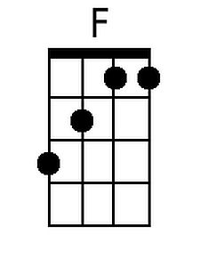 | 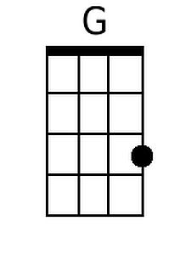 | 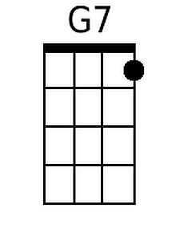 | 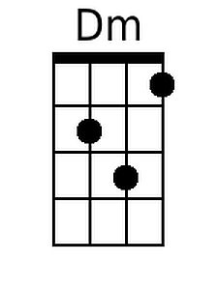 | 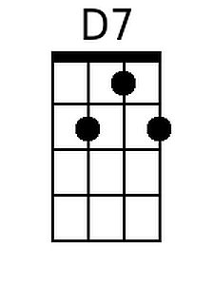

Mr. Bojangles (Jerry Jeff Walker, ca. 1965) (G) (6/8 Time)

Intro: G Bm | Em Bm

G Bm Em C D - D7
I knew a man Bo-jangles and he danced for you _ In worn out shoes
G Bm Em C D
With silver hair, a ragged shirt, and baggy pants _ The old soft shoe
C Bm Em Bm Am (A7) D
_ He jumped so high, jumped so high __ Then he'd lightly touch down.

Chorus
Em D Em D Em D G Bm | Em Bm
__ Mr. Bo-jangles __ Mr. Bo-jangles __ Mr. Bo-jangles . . . dance.

G Bm Em C D - D7
I met him in a cell in New Or-leans I was _ down and out
G Bm Em C D
He looked to me to be - the eyes of age _ as he spoke right out
C Bm Em Bm Am (A7) D - D7
_ He talked of life, talked of life __ He laughed, slapped his leg a step

G Bm Em C D - D7
He said his name Bo-jangles then he danced a licked _ across the cell
G Bm
He grabbed his pants, a better stance,
Em C D
oh he jumped so high, _ and he clicked his heels
C Bm Em Bm Am (A7) D
_ He let go a laugh, let go a laugh, __ shook back his clothes all a-round. Chorus

G Bm Em C D - D7
He danced for those at minstrel shows and county fairs _ throughout the south.
G Bm Em C D
He spoke with tears of 15 years how his dog and him _ traveled a-bout
C Bm Em Bm Am (A7) D - D7
_ His dog up and died, he up and died, __ after 20 years he still grieves.

G Bm Em C D - D7
He said I dance now at every chance in honky tonks _ for drinks and tips
G Bm Em C D
But most the time I spend behind these county bars _ 'cause I drinks a bit
C Bm Em Bm
_ He shook his head, and as he shook his head,
Am (A7) D
__ I heard someone ask him please - please. Chorus. End on G.

 |  |  |  |  |  |  |  | 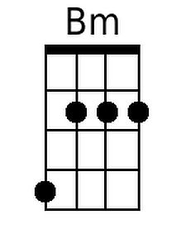
 |  |  |  |  |  |  |  | 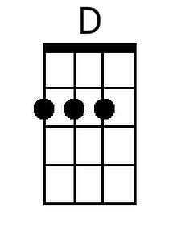
 |  |  |  |  |  |  |  | 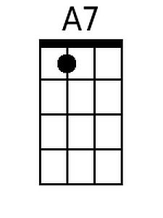
DGBE |  | 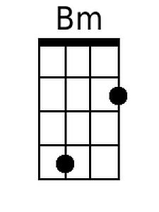 |  |  | 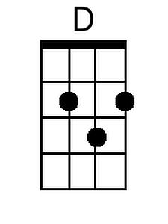 |  |  | 