Mrs. Robinson (Paul Simon)

E7
De de de de de de de de de de de de de
A A7
Do do do do do do do do do
D G C G Am E7 D
De de de de de de de de de de de de de
Chorus:
G Em
And here's to you, Mrs Robinson
G Em C
Jesus loves you more than you will know.
D
Whoa whoa whoa
G Em
God bless you please, Mrs Robinson
G Em C
Heaven holds a place for those who pray
Am E7
Hey hey hey Hey hey hey

E7
We'd like to know a little bit about you for our files
A A7
We'd like to help you learn to help yourself
D7 G
Look around you all you see are
C G Am
Sympa-thetic eyes
BARITONE
E7 D
Stroll around the grounds until you feel at home

(Chorus)

E7
Hide it in a hiding place where no one ever goes
A A7
Put in your pantry with your cupcakes
D7 G C Am
It's a little secret just the Robinson's affair
E7 D
Most of all you've got to hide it from the kids

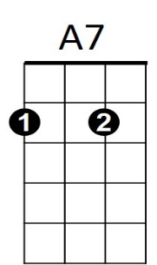

G
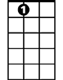



E7
A
D
C

D G Em
Koo koo kachoo, Mrs Robinson
G Em C
Jesus loves you more than you will know.
D
Whoa whoa whoa
G Em
God bless you please, Mrs Robinson
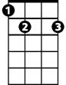
G Em C
E7
Heaven holds a place for those who pray
Am E7
Hey hey hey Hey hey hey

E7
Sitting on a sofa on a Sunday afternoon
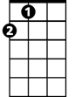
A A7
A
Going to the candidates’ debate
D7 G
Laugh about it shout about it
C Am
When you've got to choose
E7 D
Every way you look at it you'll lose
A7

G Em
Where have you gone Joe DiMaggio
G Em C
A nation turns its lonely eyes to you
D
Whoo whoo whoo
D
G Em
What's that you say Mrs Robinson
G Em C
Joltin' Joe has left and gone away
Am E7
Hey hey hey Hey hey hey



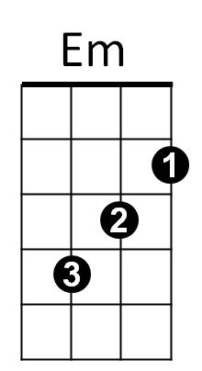
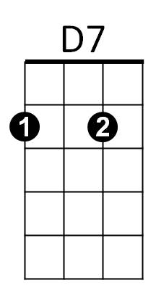
Am
D7
Em
C
Am
G

