Mustang Sally (Bonny Rice 1965)
Intro: C C7 C C7 C C7 C



C7 C C7 C C7 C
C7
C
Mustang Sally
C7 C C7 C C7 C C7 C C7 C
Guess you better slow your Mustang down
F F7
Mustang Sally, now baby
F C C7 C C7 C C7 C

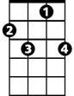
Guess you better slow your Mustang down
F
F7
G G\F#\F
You been running all over town, now
tacet C C7 C C7 C C7 C
Oh, I guess I have to put your flat feet on the ground

C7 C C7 C C7 C
All you wanna do is ride around Sally (Ride Sally, ride)
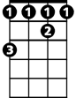

C7 C C7 C C7 C
F#
G
All you wanna do is ride around Sally (Ride Sally, ride)
F F7 F F F7 F
All you wanna do is ride around Sally (Ride Sally ride)
C7 C C7 C C7 C
All you wanna do is ride around Sally (Ride Sally, ride)
G G \ F# \ F
One of these early mornings, yeah
C C7 C C7 C C7 C
Gonna be wiping yo weeping eyes
BARITONE

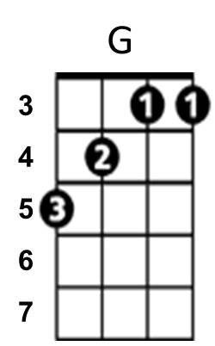
F
C7
C
C7 C C7 C
I bought you a brand new Mustang, a nineteen sixty-five,
C7 C C7
Now you come around - signifying, now woman
C C7
You don't wanna let me ride
F F7
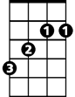
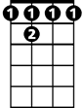
Mustang Sally, now baby
F#
F 7
F C C7 C C7 C C7 C
Guess you better slow your Mustang down
G G \ F# \ F
You been running all over town, now
tacet C C7 C C7 C C7 C
Oh, I guess I have to put your flat feet on the ground
G
C7 C C7 C C7 C
All you wanna do is ride around Sally (Ride Sally, ride)
C7 C C7 C C7 C
All you wanna do is ride around Sally (Ride Sally, ride)
F F7 F F F7 F
All you wanna do is ride around Sally (Ride Sally ride)
C7 C C7 C C7 C
All you wanna do is ride around Sally (Ride Sally, ride)

