My Wild Irish Rose (Chauncey Olcott) (1899)
Intro: G Gaug C G A7 D7 G D7

G Gaug C G
If you listen I'll sing you a sweet little song
A7 D7
Of a flower that's now drooped and dead
G Gaug C G
Yet dearer to me, yes than all of its mates
D7 G
Though each holds aloft its proud head
C G
'Twas given to me by a girl that I know
A7 D7
Since we've met, faith, I've known no repose
G Gaug C G
She is dearer by far than the world's brightest star
D7 G C G
And I call her my Wild Irish Rose

Chorus:
G D7 G G7
My Wild Irish Rose,
C D7 G
The sweetest flower that grows
D7 G
You may search everywhere,
D7 G

But none can compare
G
A A7 D D7
With my Wild Irish Rose
G D7 G G7
My Wild Irish Rose,
C D7 G
The dearest flower that grows
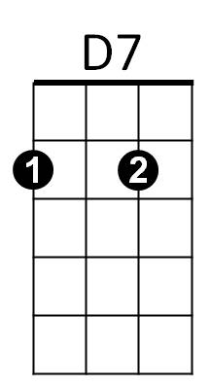
D7 G
And some day for my sake,
D7 G
She may let me take
A7 D7 G
The bloom from my Wild Irish Rose

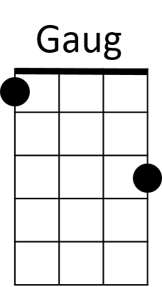
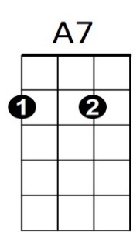
BARITONE


C
G

G Gaug
They may sing of their roses,
C G
Which by other names
A7 D7
Would smell just as sweetly, they say
G Gaug C G
But I know that my Rose would never consent
D7 G
To have that sweet name taken away
C G
Her glances are shy when-e'er I pass by
A7 D7
The bower where my true love grows
G Gaug
And my one wish has been
C G
That someday I may win
D7 G C G
The heart of my Wild Irish Rose

(CHORUS)

A7 D7 G
The bloom from my Wild Irish Rose
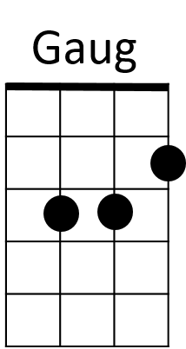
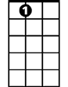
A7
C


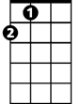

D
A
G7


D
A
G7
D7

