My Yellow Ginger Lei (Ku’u Lei ‘Awapuhi Melemele) Key C
John Ka’onoho’i’okala Ke’awehawai’i

VAMP D7 G7 C (2X)

C G7
My yellow ginger lei
C
Reveals her scent through the day
G7
Enchanting moments with you
C D7 G7 C
Make me love y ou

C G7
Ku’u lei ‘awa puhi melemele
C
I pua me ke ‘ala onaona
G7
Ho’ohihi ka mana’o ia ‘oe
C D7 G7 C
E ku’u lei ‘awapuhi

C G7
You’re as lovely as can be
C
My yellow ginger lei
G7
My heart is yearning for you
BARITONE
C D7 G7 C
My ‘awapuhi

C G7
Haina ‘ia mai
C
Ana ka pu ana
G7
My yellow ginger lei
C D7 G7 C
Makes me love you

G7
My yellow ginger lei
C D7 G7 C (2X)
Makes me love you

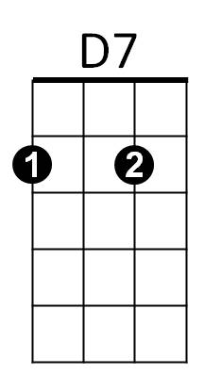

C
G7


C
D7
G7

My Yellow Ginger Lei (Ku’u Lei ‘Awapuhi Melemele) Key F
John Ka’onoho’i’okala Ke’awehawai’i

VAMP G7 C7 F (2X)

F C7
My yellow ginger lei
F
Reveals her scent through the day
C7
Enchanting moments with you
F G7 C7 F
Make me love you

F C7
Ku’u lei ‘awa puhi melemele
F
I pua me ke ‘ala onaona
C7
Ho’ohihi ka mana’o ia ‘oe
F G7 C7 F
E ku’u lei ‘awapuhi

F C7
You’re as lovely as can be
F
My yellow ginger lei
C7
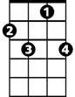My heart is yearning for you
G7
BARITONE
F
C7
F G7 C7 F
My ‘awapuhi

F C7
Haina ‘ia mai
F
Ana ka pu ana
C7
My yellow ginger lei
F G7 C7 F
Makes me love you

C7
My yellow ginger lei
F G7 C7 F (2X)
Makes me love you
G7
F
C7

My Yellow Ginger Lei (Ku’u Lei ‘Awapuhi Melemele) Key G
John Ka’onoho’i’okala Ke’awehawai’i

VAMP A7 D7 F (2X)

G D7
My yellow ginger lei
G
Reveals her scent through the day
D7
Enchanting moments with you
G A7 D7 G
Make me love you

G D7
Ku’u lei ‘awa puhi melemele
G
I pua me ke ‘ala onaona
D7
Ho’ohihi ka mana’o ia ‘oe
G A7 D7 G
E ku’u lei ‘awapuhi

G D7
You’re as lovely as can be
G
My yellow ginger lei
D7
My heart is yearning for you
BARITONE
G A7 D7 G
My ‘awapuhi

G D7
Haina ‘ia mai
G
Ana ka pu ana
D7
My yellow ginger lei
G A7 D7 G
Makes me love you

D7
My yellow ginger lei
G A7 D7 G (2X)
Makes me love you
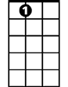
A7

G

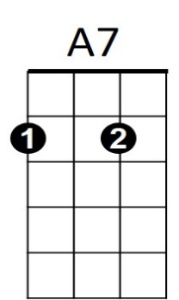
D7
G

