Never Did No Wanderin’' (by The Folksmen from 'A Mighty Wind’)

Intro: Dm


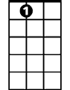


Dm C Dm F A7
C
A7
F
Dm
My mama was the cold north wind, my daddy was the so-n,
Dm C
Of a rail road man, from west of Hell,
Bb Am Dm
Where the trains don't even run.
F Dm
Never heard the whistle of a South-bound freight,
F A7




Or the singing of it's drivin' wheel... no I...
D
Gm
Bb
Am

Chorus:
Dm C Dm F
Never did no wanderin', never did no wanderin'.
Dm A7 Dm
Never did no wanderin' after all.

Dm C
They say the highway's just one big road,
Dm F A7
And it goes from here to the-re.
Dm C
And they say you carry a heavy load,
Bb Am Dm
When you're rollin' down the line some-where.
F Dm
Never seen the dance of the telephone poles,
F A7
As they go whizzin' by... no I...

(Chorus)

Gm Dm Gm A7
Never did no wanderin'... high……Never did no wanderin'... low.

Dm C
BARITONE
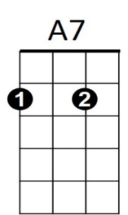
Now a sailor’s life is a life for him,
F
C
Dm
Dm F A7
But it never was for me-e.
Dm C
And I've never soared where the hawk may soar,
Bb Am Dm
Or seen what the hawk might see.

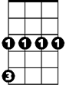
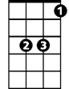
F Dm
D
Gm
Am
Bb
Never hiked to heaven on a mountain trail,
F A7
Never rolled on a river's rage... no I...

(Chorus)

Outro: Dm A7 D
Never did no wanderin' after all...

