Never, My Love (Don and Dick Addrisi, 1967) (C)
(Original key: C#)

Introductory Riff (E F G B C) (3x)

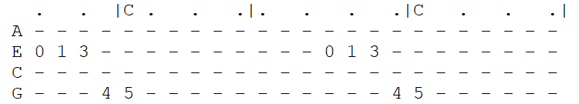
C G Bb F C
You ask me if there'll come a time when I grow tired of you.
Am C F C
Never, my love, never, my love. (-Riff------------)
C G Bb F C
You wonder if this heart of mine will lose its de-sire for you.
Am C F C
Never, my love, never, my love.

Chorus 1:
E7 Am D G C F
What makes you think love will end when you know that my whole life de-pends
Em7\ Am7\
On you? (on you) (-Riff---------------)
C G Bb F C
Da-ta-ta Da da da da Da------ Da-ta-ta Da-ta-ta da------
Am C F C
Never, my love, never, my love. (-Riff------------)
C . G . . . Bb . . . F . C .
You say you fear I'll change my mind, and I won't re-- quire---- you
Am C F C
Never, my love, never, my love.
(never, my love-------------) (never, my-- love---)

Chorus 2:
E7 Am D G C F
How can you think love will end when I've asked you to spend your whole life
Em7 Am7\ (Hold)
With me? With me?
(with me)

Outro (3x)
C G Bb F C
(-Riff------)
Am C F C
Never, my love, never, my love.
(never, my love) (never, my love)

Never, My Love (Don and Dick Addrisi, 1967) (G)
(Original key: C#)

Introductory Riff (B C D F# G) (3x)
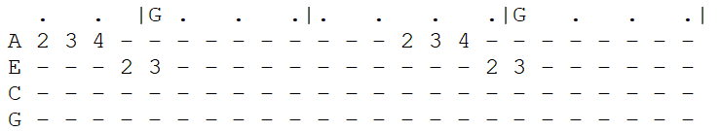
G D F C G
You ask me if there'll come a time when I grow tired of you.
Em G C G
Never, my love, never, my love. (-Riff------------)
G D F C G
You wonder if this heart of mine will lose its de-sire for you.
Em G C G
Never, my love, never, my love.

Chorus 1:
B7 Em A D G C
What makes you think love will end when you know that my whole life de-pends
Bm7\ Em7\
On you? (on you) (-Riff---------------)
G D F C G
Da-ta-ta Da da da da Da------ Da-ta-ta Da-ta-ta da------
Em G C G
Never, my love, never, my love. (-Riff------------)
G . D . . . F . . . C . G .
You say you fear I'll change my mind, and I won't re-- quire---- you
Em G C G
Never, my love, never, my love.
(never, my love-------------) (never, my-- love---)

Chorus 2:
B7 Em A D G C
How can you think love will end when I've asked you to spend your whole life
Em7 Am7\ (Hold)
With me? With me?
(with me)

Outro (3x)
G D F C G
(-Riff------)
Em G C G
Never, my love, never, my love.
(never, my love) (never, my love)

