Never, My Love (Don and Dick Addrisi, 1967) (C)
(Original key: C#)

Introductory Riff (E F G B C) (3x)
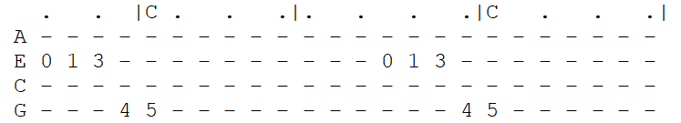
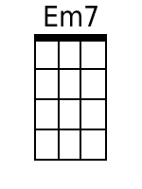
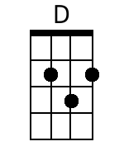
C G Bb F C  You ask me if there'll come a time when I grow tired of you.  Am C F C  Never, my love, never, my love. (-Riff------------)  C G Bb F C  You wonder if this heart of mine will lose its de-sire for you.  Am C F C  Never, my love, never, my love.  Chorus 1:  E7 Am D G C F  What makes you think love will end when you know that my whole life de-pends  Em7\ Am7\  On you? (on you) (-Riff---------------)  C G Bb F C  Da-ta-ta Da da da da Da------ Da-ta-ta Da-ta-ta da------  Am C F C  Never, my love, never, my love. (-Riff------------)  C G Bb F C  You say you fear I'll change my mind, and I won't re-quire you  Am C F C  Never, my love, never, my love.  (never, my love-------------) (never, my-- love---)  Chorus 2:  E7 Am D G C F  How can you think love will end when I've asked you to spend your whole life  Em7 Am7\ (Hold)  With me? With me?  (with me)  Outro (3x)  C G Bb F C  (-Riff------)  Am C F C  Never, my love, never, my love.  (never, my love) (never, my love) |  |  |  |  |  |  |  | 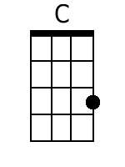 | 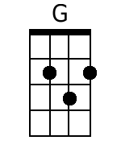
 |  |  |  |  |  |  |  | 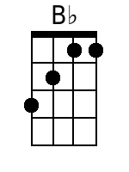 | 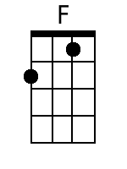
 |  |  |  |  |  |  |  | 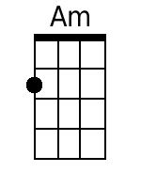 | 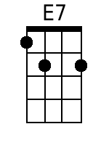
 |  |  |  |  |  |  |  | 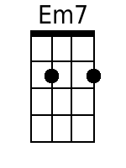 | 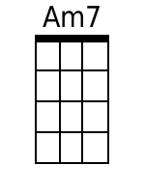
 |  |  |  |  |  |  |  | 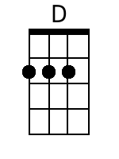
Bari
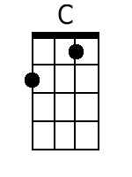 | 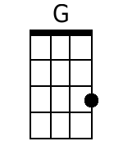 | 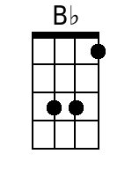 | 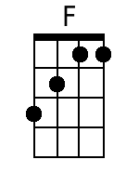 | 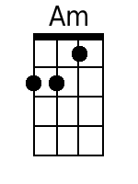 | 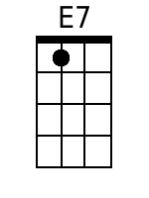 |  |  |  | 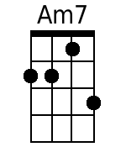

Never, My Love (Don and Dick Addrisi, 1967) (G)
(Original key: C#)

Introductory Riff (B C D F# G) (3x)

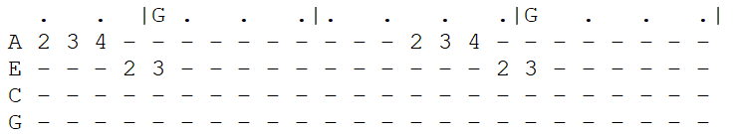
G D F C G  You ask me if there'll come a time when I grow tired of you.  Em G C G  Never, my love, never, my love. (-Riff------------)  G D F C G  You wonder if this heart of mine will lose its de-sire for you.  Em G C G  Never, my love, never, my love.  Chorus 1:  B7 Em A D G C  What makes you think love will end when you know that my whole life de-pends  Bm7\ Em7\  On you? (on you) (-Riff---------------)  G D F C G  Da-ta-ta Da da da da Da------ Da-ta-ta Da-ta-ta da------  Em G C G  Never, my love, never, my love. (-Riff------------)  G D F C G  You say you fear I'll change my mind, and I won't re-quire you  Em G C G  Never, my love, never, my love.  (never, my love-------------) (never, my-- love---)  Chorus 2:  B7 Em A D G C  How can you think love will end when I've asked you to spend your whole life  Em7 Am7\ (Hold)  With me? With me?  (with me)  Outro (3x)  G D F C G  (-Riff------)  Em G C G  Never, my love, never, my love.  (never, my love) (never, my love) |  |  |  |  |  |  |  |  | 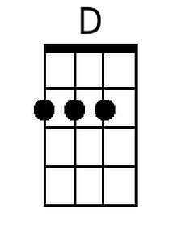
 |  |  |  |  |  |  |  | 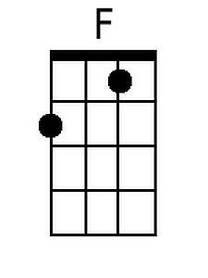
 |  |  |  |  |  |  |  | 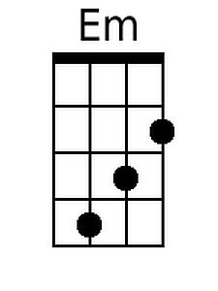 | 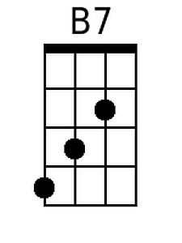
 |  |  |  |  |  |  |  | 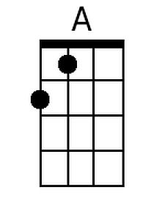 | 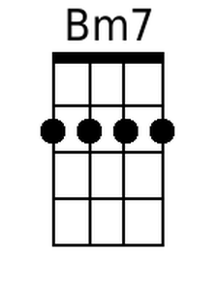
 |  |  |  |  |  |  |  | 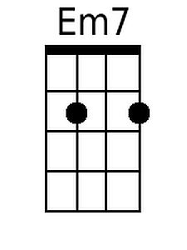
Bari
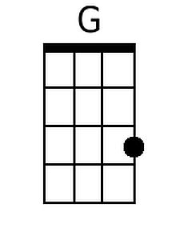 | 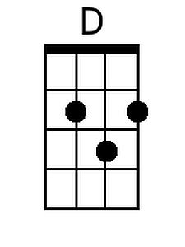 | 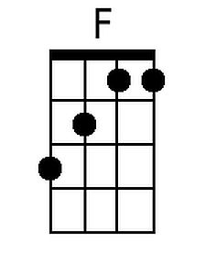 | 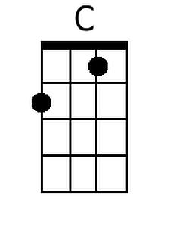 | 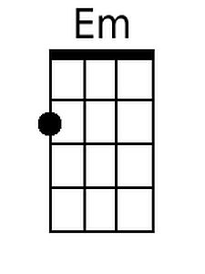 | 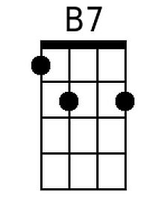 | 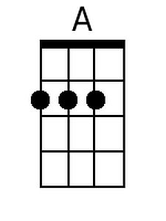 | 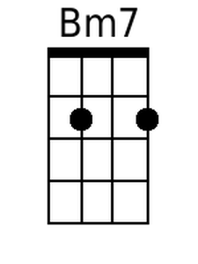 |  | 