New Kid in Town (Don Henley / Glenn Frey / John David Souther) Key F
F Gm C Gm C / Bb C F

F
There's talk on the street,
Gm C Gm C
It sounds so famil - iar;
Bb C F
Great expectations, ev'rybody's watchin' you.
C Bb C
F Gm C Gm C
People you meet they all seem to know you,
Bb C
Even your old friends
F Asus4 A7
Treat you like you're somethin' new.

Dm G Dm G
Johnny come lately, the new kid in town.
Dm G Gm C7
Ev'rybody loves you, so don't let them down.

F
You look in her eyes,
Gm C Gm C
The music begins to play,
Bb C F C Bb C
Hopeless romantics, here we go again.
F Gm C Gm C
But after a while you're lookin' the other way,
Bb C F Asus4 A7
It's those restless hearts that never mend.

Dm G Dm G
Johnny come lately, the new kid in town.
Dm G Gm C7
Will she still love you - when you're not around?

Bridge: F C / Bb C F / Bb F Gm F C7

C7 F
There's so many things you should have told her,
C7 Dm
But night after night you're willing to hold her,
G7 Bbm7 Eb Ab
Just hold her, tears on your shoul - der.
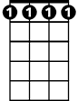
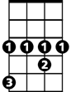
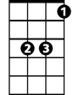
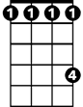
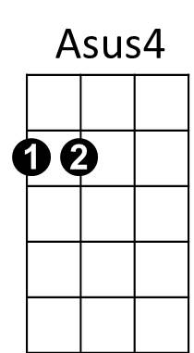
Bbm7
Ab
Eb
Db

Ab
There's talk on the street,
Bbm7 Eb Bbm7 Eb
It's there to remind you.
Db Eb
Doesn't really matter
Ab Eb Db Eb
Which side you're on.
Ab
You're walkin' away
Bbm7 Eb Bbm7 Eb
And they're talkin' behind you,
Db Eb
They will never forget you 'til somebody new
Ab C7
comes along.

Fm Bb
Where've you been lately?
Fm Bb T
here's a new kid in town.
Fm Bb Bbm7
Ev'rybody loves him (don't they?)
C7 F
And he's holdin' her and you're still around.
Am7 Bb
Ohhh ohh my my
C7 F Am7 Bb
There's a new kid in town, Ah, ah, ah
C7 F Am7 Bb Bbm7
just another new kid in town. Ah, ah, ah ah
F Dm
(Oo-oo) Ev'rybody's talkin' 'bout the new kid in town.
F Dm
(Oo-oo) Ev'rybody's walkin' like the new kid in town.
F
There's a new kid in town, (I don't want to hear it)
Dm
There's a new kid in town, (I don't want to hear it)
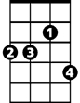
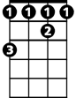
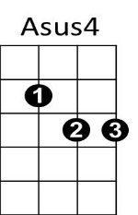
BARITONE
Bbm7
Ab
Db
Eb

