New Kid in Town (Don Henley / Glenn Frey / John David Souther) Key C
C Dm G Dm G / F G C

C Dm G Dm G
There's talk on the street, it sounds so famil - iar;
F G C G F G
Great expectations, ev'rybody's watchin' you.
C Dm G Dm G
People you meet they all seem to know you,
F G C Esus4 E7
even your old friends treat you like you're somethin' new.

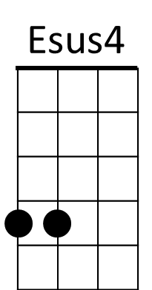
Am D Am D
Johnny come lately, the new kid in town.
Am D Dm G7
Ev'rybody loves you, so don't let them down.

C Dm G Dm G
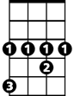
You look in her eyes, the music begins to play,
Ab
F G C G F G
hopeless romantics, here we go again.
C Dm G Dm G
But after a while you're lookin' the other way,
F G C Esus4 E7
it's those restless hearts that never mend.
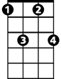
Fm7
Am D Am D
Johnny come lately, the new kid in town.
Am D Dm G7
Will she still love you - when you're not around?

Bridge: C G / F G C / F C Dm C G7
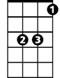
Eb
G7 C
There's so many things you should have told her,
G7 Am
but night after night you're willing to hold her,
D7 Fm7 Bb Eb
just hold her, tears on your shoul - der.
Eb Fm7 Bb Fm7 Bb
There's talk on the street, it's there to remind you.
Ab Bb Eb Bb Ab Bb
Doesn't really matter which side you're on.
Eb Fm7 Bb Fm7 Bb
You're walkin' away and they're talkin' behind you,
Ab Bb Eb G7
they will never forget you 'til somebody new comes along.

Cm F Cm F
Where've you been lately? There's a new kid in town.
Cm F
Ev'rybody loves him (don't they?)
Fm7 G7 C Em7 F
And he's holdin' her and you're still around. Ohhh ohh my my
G7 C Em7 F
There's a new kid in town, ah, ah ah
G7 C Em7 F Fm7
just another new kid in town. Ah , ah, ah ah
C Am
(Ooh-hooh) Ev'rybody's talkin' 'bout the new kid in town.
C Am
(Ooh-hooh) Ev'rybody's walkin' like the new kid in town.
Repeat to fade
C
There's a new kid in town, (I don't want to hear it)
Am
There's a new kid in town, (I don't want to hear it)
BARITONE
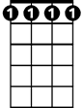
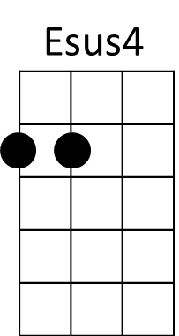
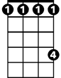
Eb
Fm7
Ab

New Kid in Town (Don Henley / Glenn Frey / John David Souther) Key F
F Gm C Gm C / Bb C F

F Gm C Gm C
There's talk on the street, it sounds so famil - iar;
Bb C F C Bb C
Great expectations, ev'rybody's watchin' you.
F Gm C Gm C
People you meet they all seem to know you,
Bb C F Asus4 A7
even your old friends treat you like you're somethin' new.
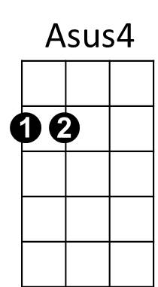
Dm G Dm G
Johnny come lately, the new kid in town.
Dm G Gm C7
Ev'rybody loves you, so don't let them down.

F Gm C Gm C
You look in her eyes, the music begins to play,
Bbm7
f C F C Bb C
hopeless romantics, here we go again.
F Gm C Gm C
But after a while you're lookin' the other way,
Bb C F Asus4 A7
it's those restless hearts that never mend.
Ab

Dm G Dm G
Johnny come lately, the new kid in town.
Dm G Gm C7
Will she still love you - when you're not around?

Bridge: F C / Bb C F / Bb F Gm F C7
Eb
Db
C7 F
There's so many things you should have told her,
C7 Dm
but night after night you're willing to hold her,
G7 Bbm7 Eb Ab
just hold her, tears on your shoul - der.
Ab Bbm7 Eb Bbm7 Eb
There's talk on the street, it's there to remind you.
Db Eb Ab Eb Db Eb
Doesn't really matter which side you're on.
Ab Bbm7 Eb Bbm7 Eb
You're walkin' away and they're talkin' behind you,
Db Eb Ab C7
they will never forget you 'til somebody new comes along.

Fm Bb Fm Bb
Where've you been lately? There's a new kid in town.
Fm Bb
Ev'rybody loves him (don't they?)
Bbm7 C7 F Am7 Bb
And he's holdin' her and you're still around. Ohhh ohh my my
C7 F Am7 Bb
There's a new kid in town, ah, ah ah
C7 F Am7 Bb Bbm7
just another new kid in town. Ah , ah, ah ah
F Dm
(Ooh-hooh) Ev'rybody's talkin' 'bout the new kid in town.
F Dm
(Ooh-hooh) Ev'rybody's walkin' like the new kid in town.
Repeat to fade
F
There's a new kid in town, (I don't want to hear it)
Dm
There's a new kid in town, (I don't want to hear it)

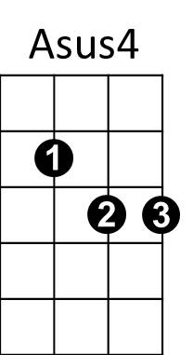
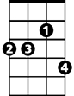
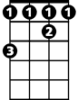
Bbm7
Ab
Db
Eb
BARITONE

