New York, New York (John Kander & Fred Ebb, 1977)
Key C – Liza Minelli Version (1977)



F
G
C
C G F 3x / C (let ring out)

G C (GFC) Dm G
Start spreading the news, I'm leaving today
C Dm G

I want to be a part of it - New York, New York
Dm
G C (GFC) Dm G
These vagabond shoes, are longing to stray
C C7
Right through the very heart of it - New York, New York

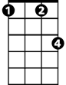

F Fm C
Fm
C7
I want to wake up in a city that doesn't sleep
Em A7 Dm G
And find I'm king of the hill - top of the heap

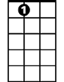
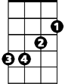
C (GFC) Dm G
A7
Em
These little town blues, are melting away
C C7
I'II make a brand new start of it - in old New York
F Fm C A7
If I can make it there, I'll make it any-where
Dm Em F G C C G F (3x)
It's up to you - New York, New York

(Repeat song from third line “These vagabond shoes…”,
Extend last two lines at ending, end with C)

BARITONE
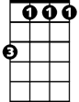


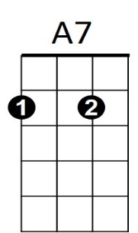
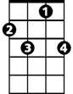

Fm
Em
F
G
C7
Dm
C

New York, New York (John Kander & Fred Ebb, 1977)

Key G – Liza Minelli Version (1977)
D
G

G D C 3x / G (let ring out)
BARITONE
D G (DCG) Am D
Start spreading the news, I'm leaving today
G Am D
Am
C
I want to be a part of it - New York, New York
D G (DCG) Am D
These vagabond shoes, are longing to stray
G G7

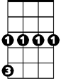
Right through the very heart of it - New York, New York
G7
Cm

C Cm G
I want to wake up in a city that doesn't sleep
Bm E7 Am D
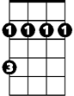
And find I'm king of the hill - top of the heap
Bm
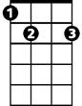
E7
G (DCG) Am D
These little town blues, are melting away
G G7
I'II make a brand new start of it - in old New York
C Cm G E7
If I can make it there, I'll make it any-where
Am Bm C D G G D C (3x)
It's up to you - New York, New York

(Repeat song from third line “These vagabond shoes…”,
Extend last two lines at ending, end in C)

Bm
G7
E7
Cm
Am
C
D
G

