Nine Pound Hammer (Merle Travis) Key C
Intro: C F7 / C G7 C


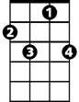

C F7
G7
F7
C
This nine pound hammer is a little too heavy
C G7 C
Buddy for my size, buddy for my size
C F7
I'm going on the mountain, gonna see my baby
C G7 C
But I ain't coming back, no I ain't coming back

Chorus:
C F7
Roll on buddy, don't you roll so slow
C G7 C
How can I roll, when the wheels won't go
C F7
Roll on buddy, pull your load of coal
C G7 C
Now, how can I pull, when the wheels won't roll

C F7
BARITONE
This nine pound hammer, killed John Henry
C G7 C
But it won’t get me, ain’t a-gonna get me

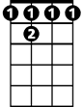

C F7
C
F7
G7
Well I’m just a poor boy, a long ways from home
C G7 C
Down in Tennessee, down in Tennessee

(Chorus)

C F7
It's a long way to Harlan, it's a long way to Hazard
C G7 C
Just to get a little brew, just to get a little brew
C F7
Well when I’m long gone, just make my tombstone
C G7 C
Out of number nine coal, out of number nine coal

(Chorus)

(Outro)
G7 C
How can I roll, roll, roll, when the wheels won't go?

Nine Pound Hammer (Merle Travis) Key G
Intro: G C7 / G D7 G

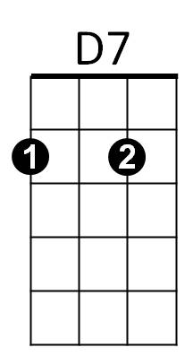

G C7
C7
G
This nine pound hammer is a little too heavy
G D7 G
Buddy for my size, buddy for my size
G C7
I'm going on the mountain, gonna see my baby
G D7 G
But I ain't coming back, no I ain't coming back

Chorus:
G C7
Roll on buddy, don't you roll so slow
G D7 G
How can I roll, when the wheels won't go
G C7
Roll on buddy, pull your load of coal
G D7 G
Now, how can I pull, when the wheels won't roll

G C7
This nine pound hammer, killed John Henry
BARITONE
G D7 G
C7
G
G7
But it won’t get me, ain’t a-gonna get me
G C7
Well I’m just a poor boy, a long ways from home
G D7 G
Down in Tennessee, down in Tennessee

(Chorus)

G C7
It's a long way to Harlan, it's a long way to Hazard
G D7 G
Just to get a little brew, just to get a little brew
G C7
Well when I’m long gone, just make my tombstone
G D7 G
Out of number nine coal, out of number nine coal

(Chorus)

(Outro)
D7 G
How can I roll, roll, roll, when the wheels won't go?

