

No Sugar Tonight / New Mother Nature
C
D
Intro: C D G A x2 / D Dsus2 x6

Dsus2 D Dsus2 D Dsus2 D Dsus2 D
Lonely feelin', deep inside, find a corner, where I can hide
Dsus2 D Dsus2 D Dsus2 D Dsus2 D C A G F D

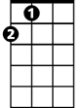
Silent footsteps, crowdin' me, sudden darkness, but I can see
G
A
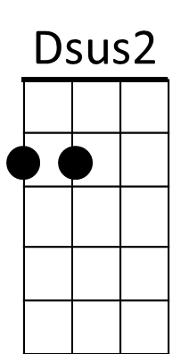
Chorus 1
D C G D
No sugar tonight in my coffee, no sugar tonight in my tea
D C G D
No sugar to stand beside me, no sugar to run with me

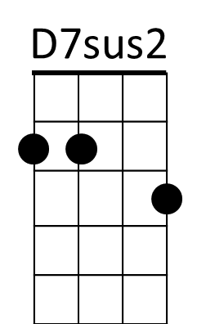
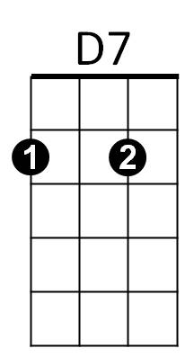
D C G D
F
Dat'n-doo-dow dow-dat'n-doo-dow, dat'n-doo-dow dow-dow-dow
D C G D C A G F D
Dat'n-doo-dow dow-dat'n-doo-dow, dat'n-doo-dow dow

D Dsus2 (x4)


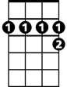
Dsus2 D Dsus2 D Dsus2 D Dsus2 D
G7
D7
In the silence, of her mind, quiet movements, where I can find
Dsus2 D Dsus2 D Dsus2 D Dsus2 D C A G F D
Grabbin' for me, with her eyes, now I'm fallin', from her skies

(Chorus 1)

Interlude: ( C D G A ) x4 *simple chords or riff slowly

(D Dsus2 ) x4 ( D7 D7sus2) x2 (gradually build tempo)

D7 D7sus2 D7 D7sus2
Jocko says yes and I believe him, when we talk about the things I say
D7 D7sus2 D7 D7sus2
She hasn't got the faith or the guts to leave him, when they're standing in each other's way
D7 D7sus2 D7 D7sus2
You're driven back in time to places you been to, you wonder what you're gonna find
D7 D7sus2 D7
You know you been wrong but it won't be long, before you leave 'em all far behind
Chorus 2:
G7 D G7 D
'Cause it's the new Mother Nature takin' over, it's the new splendid lady come to call
G7 D C D C D
It's the new Mother Nature takin' over, she's gettin' us all, she's gettin' us all

D7sus2 D7 D7sus2 D7

D7 D7sus2 D7 D7sus2
Jocko said no when I came back last time, it's lookin' like I lost a friend
D7 D7sus2 D7 D7sus2
No use callin' 'cause the sky is fallin' and I'm gettin' pretty near the end
D7 D7sus2 D7 D7sus2
A smoke-filled room in a corner basement, the situation must be right
D7 D7sus2 D7
A bag of goodies and a bottle of wine, we're gonna get it on right tonight

(Chorus 2)

D7 D7sus2 D7 D7sus2
Jocko says yes and I believe him, when we talk about the things I say
D7 D7sus2 D7 D7sus2
She hasn't got the faith or the guts to leave him, when they're standing in each other's way
D7 D7sus2 D7 D7sus2
You're driven back in time to places you been to, you wonder what you're gonna find
D7 D7sus2 D7
You know you been wrong but it won't be long, before you leave 'em all far behind

(Chorus 2)

[Outro]
D C G D
Dat'n-doo-dow dow-dat'n-doo-dow, dat'n-doo-dow dow-dow-dow
D C G D


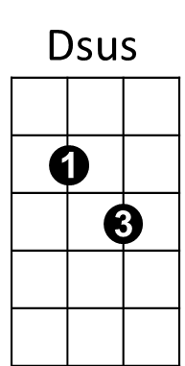
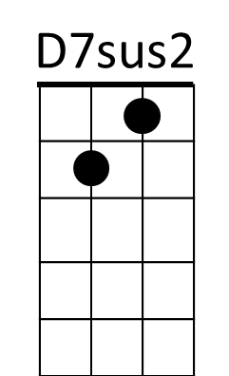
Dat'n-doo-dow dow-dat'n-doo-dow, dat'n-doo-dow dow
G7
D7
A
G
D
C
F
BARITONE

