North Shore Serenade (Na Leo Pilimehana) Key C
C




Come along take a ride to the Isle’s north side
C7
G
Dm
C
Dm
Through the winding ironwood trees
G Dm G
But be sure to take care no one follows you there
C
As you’re drifting along with the breeze
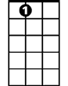


A7
F
Am
For if anyone knew where I’m taking you to
C7 F
They’d surely never depart
C Am
The magical coast that I love the most
Dm G C
Nearest and dearest my heart

Chorus:
F C
Oh my oh me oh, take me down to the North Shore
G C F C
Where the white sand rolls in the pounding surf
F C
Yeah, why don’t we go, way on out to the North Shore
G C A7
BARITONE


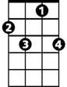
Where the sky is blue and the ocean is too
F
Dm
G
C7
C
Dm G C
Nearest to Heaven on Earth

C
Turn up the tunes, settle in for the ride
G
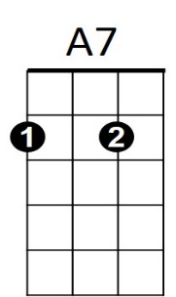
And follow the sinking sun
Am
Dm
From the top of the hill the surf’s breaking still
G C
And my nerves gently start to unwind

Every mile that I drive brings me closer to where I’ve
C7 F
Always known I should be
C Am
It’s not a big city but the sugar cane’s pretty
Dm G C
My beautiful home by the sea

(Chorus)

F C
Ooooo—la la la la la North Shore (3x to fade)

North Shore Serenade (Na Leo Pilimehana) Key F
F
Come along take a ride to the Isle’s north side
Gm
Gm
F7
Dm
C
Bb
F
Through the winding ironwood trees
C Gm C
But be sure to take care no one follows you there
F
As you’re drifting along with the breeze

For if anyone knew where I’m taking you to
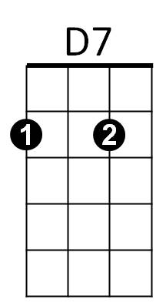
F7 Bb
They’d surely never depart
F Dm
The magical coast that I love the most
Gm C F
Nearest and dearest my heart

Chorus:
Bb F
Oh my oh me oh, take me down to the North Shore
C F
Where the white sand rolls in the pounding surf
Bb F
Yeah, why don’t we go, way on out to the North Shore
C F D7
BARITONE
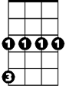
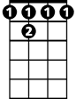
Where the sky is blue and the ocean is too
Gm
F
C
F 7
Gm C F
Nearest to Heaven on Earth

F
Turn up the tunes, settle in for the ride
C
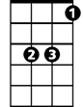

And follow the sinking sun
Dm
Bb
D7
Gm
From the top of the hill the surf’s breaking still
C F
And my nerves gently start to unwind

Every mile that I drive brings me closer to where I’ve
F7 Bb
Always known I should be
F Dm
It’s not a big city but the sugar cane’s pretty
C F
My beautiful home by the sea

(Chorus)

Bb F
Ooooo—la la la la la North Shore (3x to fade)

North Shore Serenade (Na Leo Pilimehana)

G
G7
D
Am
G
Come along take a ride to the Isle’s north side
Am
Through the winding ironwood trees
D Am D
But be sure to take care no one follows you there
G
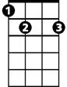
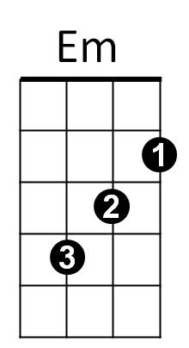
As you’re drifting along with the breeze
E7
C

For if anyone knew where I’m taking you to
G7 C
They’d surely never depart
G Em
The magical coast that I love the most
Am D G
Nearest and dearest my heart

Chorus:
C G
Oh my oh me oh, take me down to the North Shore
D G C G
Where the white sand rolls in the pounding surf
C G
Yeah, why don’t we go, way on out to the North Shore
D G E7
Where the sky is blue and the ocean is too
Am D G
BARITONE
C
Am
G
E7
G7
Em
D
Nearest to Heaven on Earth

G
Turn up the tunes, settle in for the ride
D
And follow the sinking sun
Am
From the top of the hill the surf’s breaking still
D G
And my nerves gently start to unwind

Every mile that I drive brings me closer to where I’ve
G7 C
Always known I should be
G Em
It’s not a big city but the sugar cane’s pretty
Am D G
My beautiful home by the sea

(Chorus)

C G
Ooooo—la la la la la North Shore (3x to fade)

