O Holy Night
C33C
Key C




C F C
G7
C
F
O Ho ly Night, the stars are brightly shining
G7 C
It is the night of our dear Savior's birth
F C
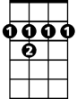

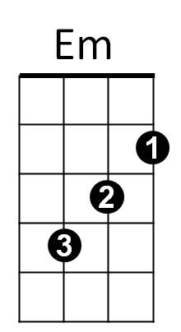
Long lay the world in sin and error pining
B7
C7
C7 Em B7 Em
'Til He appeared and the soul felt its worth
G7 C
A thrill of hope the weary world rejoices



G7 C
G
Am
Dm
For yonder breaks a new and glorious morn.

Am Em
Fall on your knees,
Dm Am
O hear the angels voices.
C G7 C F
O ni-ght ~ divine,
C G7 C
BARITONE

O night - when Christ was born
F
C
G7
G C Dm C G7 C
O night di-vi-ne, O night, O night divine.

Repeat entire song
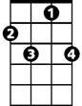
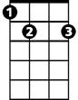
Em
C7
B7


G
Dm
Am

O Holy Night
C 33F
Key F

F Bb F
C7
Bb
F
O Holy Night, the stars are brightly shining
C7 F
It is the night of our dear Savior's birth
Bb F
Long lay the world in sin an d error pining
Dm
E7
Am
Am E7 Am
'Til He appeared and the soul felt its worth
C7 F
A thrill of hope the weary world rejoices
C7 F
For yonder breaks a new and glorious morn.
C
Gm
F7

Dm Am
Fall on your knees,
Gm Dm
O hear the angels voices.
F C7 F Bb
O ni-ght ~ divine,
F C7 F
BARITONE
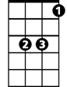
O night - when Christ was born
C7
Bb
F
C F Gm F C7 F
O night di-vi-ne, O night, O night divine.

Repeat entire song
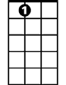
E7
Dm
Am

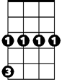
Gm

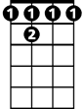
C
F 7

