O Little Town Of Bethlehem
C 34
Intro: last 2 lines of verse

C Dm
O little town of Bethlehem,
C G7 C
How still we see thee lie!
A7 Dm
Above thy deep and dreamless sleep,
C G7 C
The silent stars go by.
Am Dm E7
Yet in thy dark streets shineth
Am E7
The everlasting Light,
C Dm
The hopes and fears of all the years,
C G7 C
Are met in thee tonight.

C Dm
O morning stars, together
C G7 C
Proclaim thy holy birth
A7 Dm
And praises sing to God, the King,
C G7 C
And peace to men on earth.
Am Dm E7
For Christ is born of Mary,
Am E7
And gathered all above,
C Dm
While mortals sleep, the angels keep
C G7 C
Their watch of wondering love.
C Dm
How silently, how silently,
C G7 C
The wondrous Gift is giv'n!
A7 Dm
So God imparts to human hearts
C G7 C
The blessings of His heaven.
Am Dm E7
No ear may hear His coming,
Am E7
But in this world of sin,
C Dm
Where meek souls will receive Him still,
C G7 C
The dear Christ enters in.

C Dm
Where children pure and happy,
C G7 C
Pray to the blessed child.
A7 Dm
Where mis-ery cries out to thee,
C G7 C
Son of the mother mild;
Am Dm E7
Where charity stand watching,
Am E7
And faith holds wide the door,
C Dm
The dark night wakes, the glory breaks,
C G7 C
And Christ-mas comes once more.




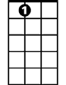
C
Am
Dm
G7
A7

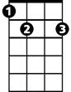
E7

BARITONE
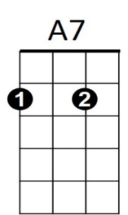



E7
Am
G7
C
Dm

