
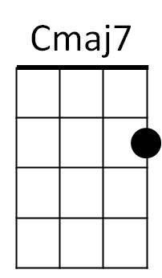
Our House (Graham Nash, ca. 1969) – Key of C
C
C Cmaj7 Am C F
I'll light the fire, you place the flowers in the vase
C F
That you bought today
C Cmaj7 Am C


Staring at the fire for hours and hours
F
Am
F C F G F G C Cmaj7
While I listen to you play your love songs all night long for me
Am C F G#
Only for me

G
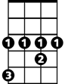

C Cmaj7 Am C
G#
Dm
Come to me now and rest your head for just five minutes
F C F
Every - thing is done
C Cmaj7 Am C
Such a cozy room the windows are illuminated
F C F G F G C Cmaj7
BARITONE

By the evening sunshine through them fiery gems for you
F
C
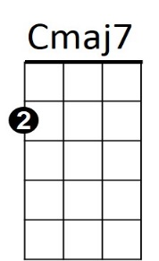
Am C F G#
Am
Only for you

CHORUS:
C Cmaj7 Am C
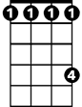

Our house, is a very, very, very fine house
G
G#
Dm
F C
With two cats in the yard
F C
Life used to be so hard
F C F Dm F
Now everything is easy 'cause of you …. and - I
C Cmaj7 Am C F C F G
Lala Ladadada Ladadada Ladadadada Dadadada Dadadada Dadadada Dadadada
C Cmaj7 Am C F G#
Lala Ladadada Ladadada Ladadadada Dadadada Dadada dada
(CHORUS)

(slowly) C Cmaj7 Am C F
I'll light the fire While you place the flowers in the vase
G# C
That you bought toda - -a – a—ay
Our House (Graham Nash, ca. 1969) – Key of G
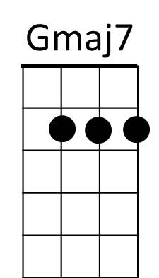
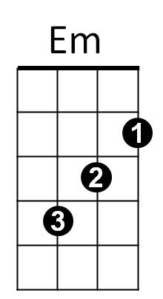
G
G Gmaj7 Em G C
I'll light the fire, you place the flowers in the vase
G C
That you bought today

G Gmaj7 Em G
D
C
Staring at the fire for hours and hours
C G C D C D G Gmaj7
While I listen to you play your love songs all night long for me
Em G C Eb
Only for me
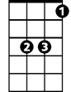
Eb
G Gmaj7 Em G
Am
Come to me now and rest your head for just five minutes
C G C
Every - thing is done
G Gmaj7 Em G
Such a cozy room the windows are illuminated
C G C D C D G Gmaj7
BARITONE
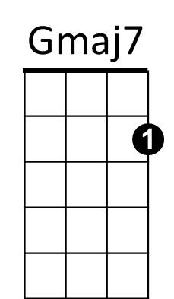
By the evening sunshine through them fiery gems for you
Em G C Eb
C
Em
G
Only for you

CHORUS:
G Gmaj7 Em G
Our house, is a very, very, very fine house
D
Eb
Am
C G
With two cats in the yard
C G
Life used to be so hard
C G C Am C
Now everything is easy 'cause of you …. and - I
G Gmaj7 Em G C G C D
Lala Ladadada Ladadada Ladadadada Dadadada Dadadada Dadadada Dadadada
G Gmaj7 Em G C D#
Lala Ladadada Ladadada Ladadadada Dadadada Dadada dada
(CHORUS)

(slowly) G Gmaj7 Em G C
I'll light the fire While you place the flowers in the vase
Eb G
That you bought toda - -a – a—ay

