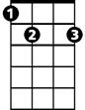Panama Red (P. Rowan) Key C
C
G
F
Am
E7
D
Intro: G C

Chorus:
Am G
Panama Red, Panama Red,
F D G
He'll steal your woman then he'll rob your head.
Am G
Panama Red, Panama Red,
E7 F
On his white horse Mescalito, he comes breezin' thru town.
G C
Bet your woman is up in bed with ol' Panama Red.

C
The judge don't know when Red's in town,
F
He keeps well hidden under ground.
G C
Everybody's actin' lazy, fallin' out or hangin' round.
C F
My woman said, Hey Pedro, you're actin' crazy like a clown.
G C
Nobody feels like workin' Panama Red is back in town.

(Chorus)

C F
Everybody's lookin' out for him ‘cause they know Red satisfies.
G C
Little girls like to listen to him sing and tell sweet lies.
C F
But when things get too confusin' honey, you're better off in bed.
G C
I'll be searchin' all the joints in town for Panama Red.
BARITONE
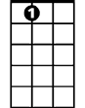(Chorus) 3x to fade
E7
D
F
Am
C
G

Panama Red (P. Rowan) Key F
Intro C F
C
F
BARITONE

Chorus:
Dm C
Panama Red, Panama Red,
Bb G C
G
Dm
He'll steal your woman then he'll rob your head.
Dm C
Panama Red, Panama Red,
A7 Bb
On his white horse Mescalito, he comes breezin' thru town.
C F
Bb
A7
Bet your woman is up in bed with ol' Panama Red.

F
The judge don't know when Red's in town,
Bb
He keeps well hidden underground.
C F
Everybody's actin' lazy, fallin' out or hangin' round.
F Bb
My woman said, Hey Pedro, you're actin' crazy like a clown.
C F
Nobody feels like workin' Panama Red is back in town.

(Chorus)

F Bb
Everybody's lookin' out for him ‘cause they know Red satisfies.
C F
Little girls like to listen to him sing and tell sweet lies.
F Bb
But when things get too confusin' honey, you're better off in bed.
C F
I'll be searchin' all the joints in town for Panama Red.

(Chorus) 3x to fade
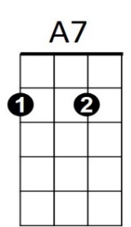
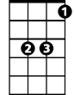
F
Dm
G
Bb
C

Panama Red (P. Rowan)
Intro D G
G
D

Chorus:
Em D
Panama Red, Panama Red,
C A D
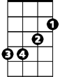He'll steal your woman then he'll rob your head.
C
Em
Em D
Panama Red, Panama Red,
B7 C
On his white horse Mescalito, he comes breezin' thru town.
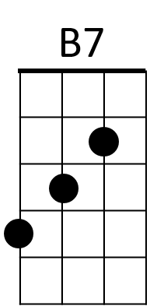
D G
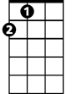Bet your woman is up in bed with ol' Panama Red.
A

G
The judge don't know when Red's in town,
C
He keeps well hidden underground.
D G
Everybody's actin' lazy, fallin' out or hangin' round.
G C
My woman said, Hey Pedro, you're actin' crazy like a clown.
D G
Nobody feels like workin' Panama Red is back in town.

(Chorus)

G C
Everybody's lookin' out for him ‘cause they know Red satisfies.
D G
Little girls like to listen to him sing and tell sweet lies.
G C
But when things get too confusin' honey, you're better off in bed.
D G
I'll be searchin' all the joints in town for Panama Red.
BARITONE
(Chorus) 3x to fade
D
G
Em
C
B7
A

