Intro: Melody for last two lines of chorus

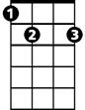

C E7 A7
E7
C
Now they make new movies in old black and white
D7 G7
With happy endings, where nobody fights
C E7 A7
So if you find yourself in that nostalgic rage
D7 G7
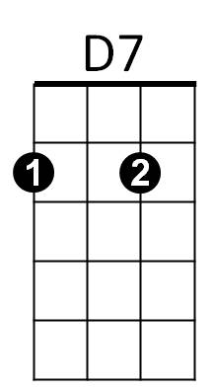
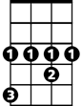

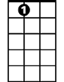

Honey, jump right up and show your age
G#
Dm
A7
G7

Chorus:
C E7 A7
I wish I had a pencil thin mustache
D7 G7 C
The "Boston Blackie" kind
C E7 A7


A two toned Ricky Ricardo jacket
F
C7
D7 G7
And an autographed picture of Andy Devine
C C7
Oh I remember bein' buck-toothed and skinny
F G#
Writin' fan letters to Sky's niece Penny
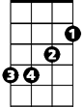
C E7 A7
Em
Oh I wish I had a pencil thin mustache
D7 G7 C
Then I could solve some mysteries too

Dm A7 Dm A7
Oh it's Bandstand, Disneyland, growin' up fast
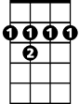
Dm A7 Dm
B7
Drinkin' on a fake I.D.
Em B7 Em B7
And Rama of the jungle was everyone's Bawana
D7 G7
But only jazz musicians were smokin' marijuana
C E7 A7
Yeah, I wish I had a pencil thin mustache
D7 G7 C
Then I could solve some mysteries too

Instrumental bridge first two lines of verse

Dm A7 Dm A7
But then it's flat top, dirty bop, coppin' a feel
BARITONE
Dm A7 Dm
Grubbin' on the livin' room floor (so sore)
Em B7 Em B7
Yeah, they send you off to college, try to gain a little knowledge,
D7 G7
C
E7
But all you want to do is learn how to score

C E7 A7
Yeah, but now I'm gettin' old, don't wear underwear
D7 G7
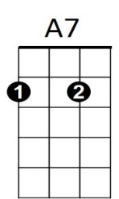
I don't go to church and I don't cut my hair
D7
G7
C E7 A7
But I can go to movies and see it all there
D7 G7 C
Just the way that it used to be


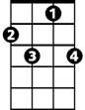
C E7 A7
F
C7
That's why I wish I had a pencil thin mustache
D7 G7 C
The "Boston Blackie" kind,
C E7 A7
A two-toned Ricky Ricardo jacket

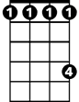
D7 G7
Em
G#
And an autographed picture of Andy Devine
C C7
Oh, I could be anyone I wanted to be
F G#
Maybe suave Errol Flynn or a Sheik of Araby
C E7 A7

If I only had a pencil thin mustache
Dm
B7
D7 G7 C
Then I could do some cruisin' too
C
Yeah, Bryl-cream, a little dab'll do yah
D7 G7 C
Oh, I could do some cruisin' too

