People are Strange (Jim Morrison)


Dm
Am
Am
People are strange
Dm Am
When you’re a Stranger
Dm Am E7 Am
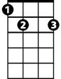

Faces look ugly when you’re alone
E7
C

Am
Women seem wicked
Dm Am
When you’re unwanted
Dm Am E7 Am
Streets are uneven when you’re down

Refrain:
BARITONE

Am E7
Dm
Am
When you’re strange
C E7
Faces come out in the rain
When you’re strange
C E7

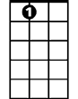
No one remembers your name
C
E7
When you’re strange, when you’re strange

(Repeat entire song)

(Refrain)

E7 (hold last chord at end)
When you’re strange........

