People (Jule Styne / Bob Merrill)
G Am


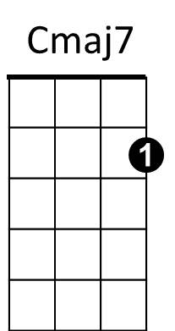

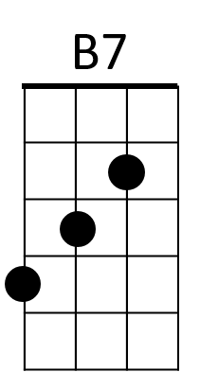
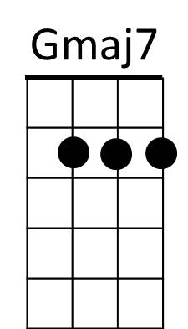



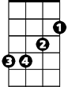
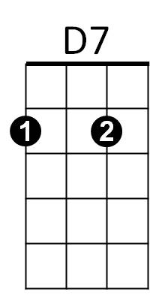
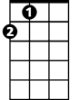
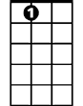

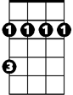
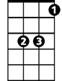
G Am G Am D
G7
Dm
D
G
Am
Em
A
A7
C
Bm
Eb
People People who need people
Gmaj7 B7
Are the luckiest people in the world
Em A7
We're children, needing other children
Em A D
And yet letting a grown-up pride
Em D
Hide all the need inside
Em A D D7
Acting more like children - than children

G Am G Am
Lovers, Are very special people
D G Gmaj7 Dm
They're the luckiest people in the world
G C Bm G
With one person, one very special person
C Cmaj7
A feeling deep in your soul
G A
Says you were half now you're whole
G Em
No more hunger and thirst
Am G G7
BARITONE


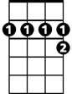
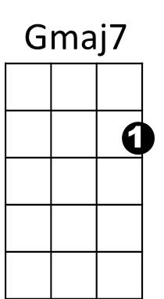
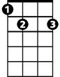

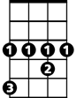
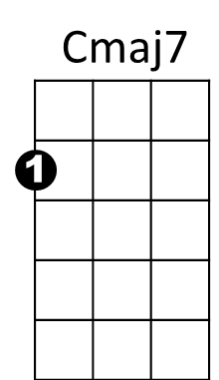
But first be a person who needs people
Bm
D
C
G7
A7
A
D7
Am
B7
G
Em
Dm
Eb
C Am
People who need people
G Am G G7
Are the luckiest people in the world

C Bm G
With one person, one very special person
C Cmaj7
A feeling deep in your soul
G A
Says you were half now you're whole
G Em
No more hunger and thirst
Am G G7
But first be a person who needs people
C Eb
People who need people
G Am Eb G
Are the luckiest people - in the world

