Peter Cottontail (Steve Nelson & Jack Rollins, 1949) (C)
Peter Cottontail by Gene Autry (1950) – Version 2

C F  Here comes Peter Cottontail hoppin' down the bunny trail  G7 C  Hippity hoppity Easter's on its way  F  Bringing every girl and boy baskets full of Easter joy  G7 C  Things to make your Easter bright and gay  F C  He's got jelly beans for Tommy, colored eggs for sister Sue.  F D7 G7  There's an orchid for your Mommy, and an Easter bonnet too.  Chorus  C F  Here comes Peter Cottontail hopping down the bunny trail  G7 C  Hippity hoppity happy Easter day.  Instrumental Chorus  C F  Here comes Peter Cottontail hoppin' down the bunny trail  G7 C  Look at him stop, and listen to him say,  F  “Try to do the things you should.” Maybe if you’re extra good,  G7 C  He’ll roll lots of Easter eggs your way.  F C  You'll wake up on Easter morning, and you'll know that he was there.  F D7 G7  When you find those chocolate bunnies that he's hiding every-where. Chorus  Outro  G7 C  Hippity hoppity happy Easter day. |  |  |  |  |  |  | 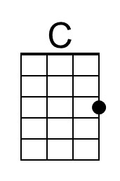
 |  |  |  |  |  |  | 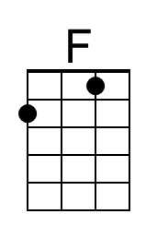
 |  |  |  |  |  |  | 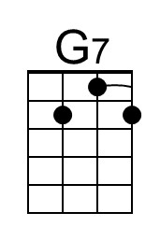
 |  |  |  |  |  |  | 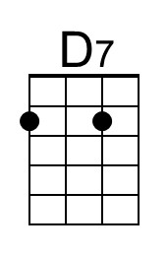
 |  |  | Bari | 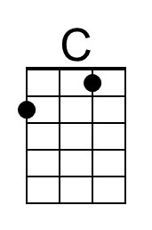 | 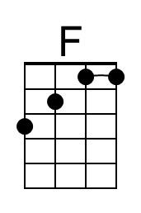  F | 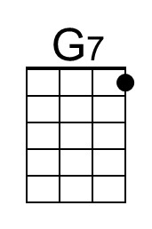 | 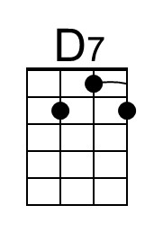


Peter Cottontail (Steve Nelson & Jack Rollins, 1949) (G)
Peter Cottontail by Gene Autry (1950) – Version 2

G C  Here comes Peter Cottontail hoppin' down the bunny trail  D7 G  Hippity hoppity Easter's on its way  C  Bringing every girl and boy baskets full of Easter joy  D7 G  Things to make your Easter bright and gay  C G  He's got jelly beans for Tommy, colored eggs for sister Sue.  C A7 D7  There's an orchid for your Mommy, and an Easter bonnet too.  Chorus  G C  Here comes Peter Cottontail hopping down the bunny trail  D7 G  Hippity hoppity happy Easter day.  Instrumental Chorus  G C  Here comes Peter Cottontail hoppin' down the bunny trail  D7 G  Look at him stop, and listen to him say,  C  “Try to do the things you should.” Maybe if you’re extra good,  D7 C  He’ll roll lots of Easter eggs your way.  C G  You'll wake up on Easter morning, and you'll know that he was there.  C A7 D7  When you find those chocolate bunnies, that he's hiding every-where. Chorus  Outro  D7 G  Hippity hoppity happy Easter day. |  |  |  |  |  |  | 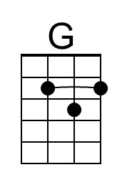
 |  |  |  |  |  |  | 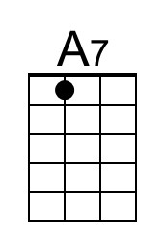
 |  |  | Bari | 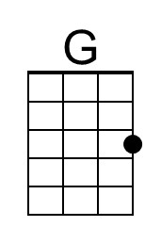 |  |  | 