Pidgin English Hula (Charles E. King)
VAMP: G7 C7 F (2x)



F
F
C7
G7
Honolulu - pretty girl stop
G7
Too muchee goo-roo king
C7
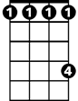
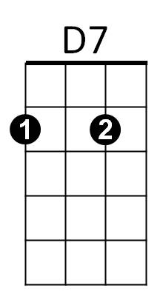

Numbah one sweet,
Db
Bb
F C7
Naughty eyes make, oh, oh, ah hah!
F
You bet I know --- You no get chance
G7
Naddah fella she sweetheart
Db
4
Bb F D7
But today, pilikia got
G7 C7 F
She too much huhu for him

Db
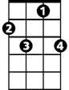
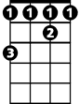
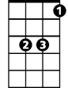
And I say- Ah-sa-matta you las’ night
BARITONE
C7
G7
F
Db
D7
Bb
F
Oh, you no come see ma-ma
C7
I - tink - so you no likee me no moah
F
You too muchee like ‘naddah girl
Db
‘Naddah fella likee me too
F
Him numbah one goo-roo king
G7
He too much aloha,
C7 F
A-ha, ha, ha, --- a-ha, -ha, ha auwe’, auwe’
G7 C7 F (VAMP 2x)
A-ha, -ha ha, ----a-ha, -ha, ha, auwe’, auwe’

(REPEAT ENTIRE SONG)

