Yellow Bird
(Michel Mauléart Monton / Oswald Durand) (English lyrics by Alan and Marilyn Bergman)




C G7 C
C
G7
F
Yellow bird, up high in banana tree.
G7 C
Yellow bird, you sit all alone like me.
F C
Did you lady friend leave the nest again?
G7 C
That is very sad, makes me feel so bad.
F C
You can fly away, in the sky away.
G7 C
You more lucky than me.

F G7 C
I also had a pretty girl, she’s not with me today.
F
They’re all the same those pretty girls.
G7 C
Take tenderness, then they fly away.

C G7 C
Yellow bird, up high in banana tree.
G7 C
Yellow bird, you sit all alone like me.
F C


Better fly away, in the sky away
C
G7
F
BARITONE
G7 C
Picker coming soon, pick from night to noon
F C
Black and yellow you, like banana too
G7 C
They might pick you someday

F G7
Wish that I were a yellow bird, I’d fly away with you.
F G7 C
But I am not a yellow bird, so here I sit - nothing I can do.
C
Yell ow bird, yellow bird, yellow bird

Stand By Me (Ben E. King)


INTRO: C Am F G C
C
G
F
Am
C
When the night has come
Am
And the land is dark
F G C
And the moon is the only light we'll see
Am
No I won't be afraid, oh I won't be afraid
F G C
Just as long as you stand, stand by me

CHORUS:
G C Am
And darlin', darlin', stand by me, oh stand by me
F G C
BARITONE

Oh stand, Stand by me, stand by me
G
F
C
Am

C
If the sky that we look upon
Am
Should tumble and fall
F G C
Or the mountains should crumble to the sea
Am
I won't cry, I won't cry, no I won't shed a tear
F G C
Just as long as you stand, stand by me

(CHORUS)

G
Whenever you’re in trouble, won’t you
C Am
Stand by me, oh stand by me
F G C
Oh stand, Oh stand, stand by me
F G C
Oh stand, Oh stand, stand by me

As Tears Go By - Rolling Stones


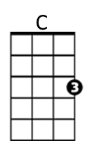
Intro: C D F G7
F
D

C D F G7
It is the evening of the da-ay
C D F G7
I sit and watch the children pla-ay
F G7
G7
Am
Smiling faces I can see
C Am
But not for me
F G7
I sit and watch as tears go by

C D F G7
My richness can't buy everythi-ing
C D F G7
I want to hear the children si-ing
F G7
All I hear is the sound
C Am
BARITONE
of rain falling on the ground
C
D
F G7
I sit and watch as tears go by

C D F G7
It is the evening of the da-ay
C D F G7
G7
F
I sit and watch the children pla-ay
F G7
Doing things I used to do
C Am
Thinking of you
F G7
Am
I sit and watch as tears go by

OUTRO (2x)
C D F G7
Hmm Hmm Hmm Hmm Hmm Hmm Hmm Hmm

Black is Black (Anthony Hayes / Michelle Grainger / Steve Wadey)
Intro: Dm C (4x)
Dm C
C
G
Dm
Black is black, I want my baby back
Dm G G7 C
It's gray, it's gray, since she went away, woh woh
C Dm G C
What can I do, 'cause I - I - I - I -I, I'm feelin' blue
F
D
G7

Dm C
If I had my way, she'd be back today
Dm G G7 C
But she don’t intend, to see me again, oh oh
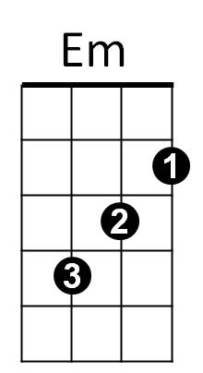
C Dm G C
What can I do, 'cause I - I - I - I -I, I'm feelin' blue

Reprise:
Dm Em
I can't choose, it's too much to lose
F
When our love's too strong
BARITONE

D
G
C
Dm
Whoooo- Maybe if she would come back to me,
G Em G7 (PAUSE)
Then it can't go wrong

Dm C
Bad is bad, that I feel so sad
G7
F
D
Dm G G7 C
It's time, it's time, that I found peace of mind, oh oh
C Dm G C
What can I do, 'cause I - I - I - I -I, I'm feelin' blue

(Reprise)
Em

Dm C
Black is black, I want my baby back
Dm G G7 C
It's gray, it's gray, since she went away, woh woh
C Dm G C
What can I do, 'cause I - I - I – I - I, I'm feelin' blue
Dm G C C F G C
'Cause I - I - I - I -I, I'm feelin' blue,
Peggy Sue (Buddy Holly)
C

Intro: C F C G (2x)

C F C F C
If you knew Peggy Sue, then you'd know why I feel blue
F
F C F C
About Peggy, my Peggy Sue
G F C F C G
Oh, well, I love you gal, yes, I love you Peggy Sue.

C F C F C
G
Peggy Sue, Peggy Sue, Oh how my heart yearns for you
F C F C
Oh, Pa-he-ggy, my Peggy Sue;
G F C F C G
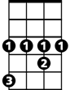
Oh, well, I love you gal, yes, I love you, Peggy Sue.
G#

Reprise:
C G# C
Peggy Sue, Peggy Sue, pretty, pretty, pretty, pretty, Peggy Sue,
F C F C
BARITONE
Oh, my Peggy, my Peggy Sue
F
C
G F C F C G
Oh, well, I love you gal, I need you, Peggy Sue.

C F C F C
I love you Peggy Sue, with a love so rare and true,
G
F C F C
Oh, Peggy, My Peggy Sue;
G F C F C
Oh, well, I love you gal, and I want you, Peggy Sue.
G#
(Repeat from Reprise)
4

G F C F C
Oh, well, I love you gal, yes, I want you, Peggy Sue.

I Saw Her Standing There (John Lennon / Paul McCartney)

Intro: 1 – 2- 3 – FIRE! G
G7
C
G

G
Well she was just seventeen
C G
You know what I mean
G7 D D7
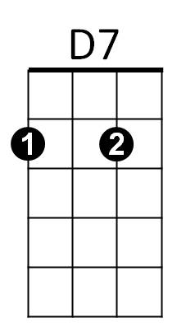
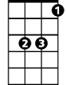
And the way she looked was way beyond compare
Eb
D
G G7 C Eb
So how could I dance with another, Oh,
G D G
When I saw her standing there

C G
Well she looked at me, and I, I could see
G7 D D7
That before too long, I'd fall in love with her
G G7 C Eb
She wouldn't dance with another Oh,
G D G
When I saw her standing there

Chorus:
C C7
Well my heart went boom - When I crossed that room
D C
BARITONE
And I held her hand in mine
C
G7
G

G
Oh we danced through the night
C G
And we held each other tight
G7 D D7
D7
D
Eb
And before too long, I fell in love with her
G G7 C Eb
Now I'll never dance with another - Oh,
G D G
When I saw her standing there

(Repeat from Chorus)

D G
Oh, since I saw her standing there
D G
Yeah, well since I saw - her – stan-ding there

