Please Please Me (Lennon / McCartney)
Intro: G




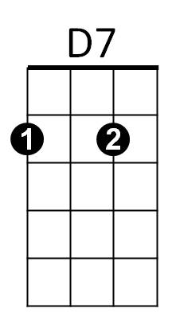
G C G Bb C D7
C
G
Bb
Last night I said these words to my girl
G C G
I know you never even try girl

Chorus:
C Am
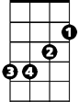

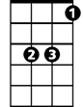
Come on (come on), come on (come on)
Em
Am
Eb
Em C
Come on (come on), come on (come on)
G C
Please please me, whoa yeah
D7 G
Like I please you

G C G Bb C D7
You don't need me to show the way girl
G C G
Why do I always have to say girl

(Chorus)

Bridge:
C
I don't want to sound complaining
D7 G C G
But you know there's always rain in my heart (in my heart)
C


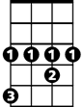
I do all the pleasing with you
Em
G
C
Bb
D7
Eb
BARITONE
D7 G
It's so hard to reason with you
C D7 G
Oh yeah, why do you make me blue

(First Verse)


(Chorus)
Am

G C
Please please me, whoa yeah
D7 G Eb D7 G
Like I please you

