Radio Ga Ga (Roger Taylor)
G Am C Am C G x2

C G

Radio
G
G
I'd sit alone and watch your light
Am
My only friend through teenage nights
C
And everything I had to know
Am C G

I heard it on my ra - dio
Am

G
You gave them all those old time stars
Am
Through wars of worlds, invaded by Mars
C
You made 'em laugh, you made 'em cry
Am C G C G

You made us feel like we could fly - Ra - dio
C

G
So don't become some background noise
Am
A backdrop for the girls and boys
C
Who just don't know or just don't care
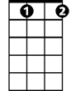
Dbdim
Dbdim
And just complain when you're not there
G
You had your time, you had the power
D
You've yet to have your finest hour
C G C G
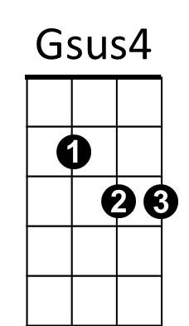

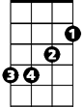
Ra - dio Ra - dio
D
Em

Gsus4 C G
All we hear is, radio ga ga,
C G C G
Radio goo goo, radio ga ga
Gsus4 C G
All we hear is, radio ga ga
C G
Radio blah blah
Am C D
Radio what's new
Em D G
Radio, someone still loves you
G Am C Am C G

G
We watch the shows, we watch the stars
G
Am
On videos for hours and hours
C
We hardly need to use our ears
Am C G

How music changes through the years
Am

G
Let's hope you never leave old friend
Am
Like all good things on you we depend
C

So stick around cos we might miss you
C
Dbdim
When we grow tired of all this visual
G
You had your time, you had the power
D
You've yet to have your finest hour
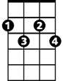
C G C G
Dbdim
D
Ra - dio Ra - dio

N.C.
All we hear is radio ga ga
Radio goo goo radio ga ga
All we hear is radio ga ga
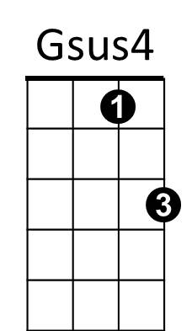
Radio goo goo radio ga ga
Em
Gsus4 C G
All we hear is, radio ga ga
C G
Radio blah blah
Am C D
Radio what's new
Em D G
Someone still loves you

G Am C Am C G / G Am C Dbdim

G
You had your time, you had the power
D
You've yet to have your finest hour
C G
Ra – dio

G Am / C Dbdim / G D

