Raindrops Keep Fallin’ On My Head (Burt Bacharach / Hal David)
Intro: C G F G (2X)


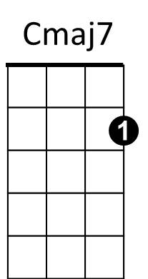

C Cmaj7
G7
C
F
Raindrops keep fallin’ on my head
C7 F Em7
And just like the guy whose feet are too big for his bed
A7 Em7 A7 Dm G7
Nothing seems to fit - those raindrops are fallin’ on my head
TACET C Cmaj7
They keep fallin’ - so I just did me some talking to the sun
C7 F Em7
And I said I didn't like the way he got things done
A7 Em7 A7 Dm G7
Sleeping on the job - those raindrops are fallin’ on my head
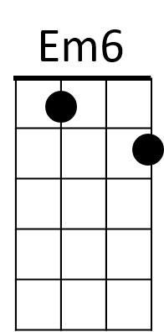



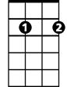
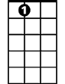
They keep fallin’ – (PAUSE)
C7
Dm
G
Em7
A7

Reprise:
TACET C Em7
But there's one thing - I know
F G7 Em7
The blues they send to meet me won't defeat me
Em6 Dm G7 F G F G
It won't be long till happiness steps up to greet me

C Cmaj7
Raindrops keep fallin’ on my head
C7 F Em7
But that doesn't mean my eyes will soon be turning red
A7 Em7 A7 Dm G7
Crying's not for me - cause I'm never gonna stop the rain by complaining
C F G7 C
Because I'm free - nothings worrying me

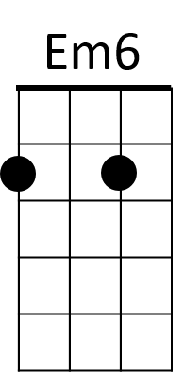
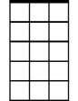

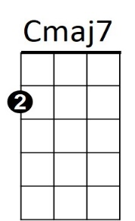
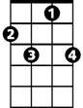
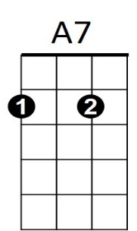

(Instrumental (kazoos?) Reprise, sing last line) Last verse - extend last line
Em7
C
G
F
C7
Dm
G7
BARITONE

