
Raindrops Keep Falling On My Head (Burt Bacharach & Hal David, 1969) (C)
Raindrops Keep Falling On My Head by B. J. Thomas

Intro (4 Measures) | C G | F G | (2X) (Pattern: ↓_↓↑↓↑ ↓_↓↑↓↑ )  C Cmaj7  Raindrops keep falling on my head  C7 F Em7  And just like the guy whose feet are too big for his bed  A7 Em7 A7 Dm G7  Nothing seems to fit - those raindrops are falling on my head  TACET C Cmaj7  They keep falling - so I just did me some talking to the sun  C7 F Em7  And I said I didn't like the way he got things done  A7 Em7 A7 Dm G7  Sleeping on the job - those raindrops are falling on my head  They keep falling – (PAUSE – Palm Mute or Hold)  Reprise  TACET C Em7  But there's one thing _ I know,  F G7 Em7  The blues they send to meet me won't de-feat me  Em6 Dm G7 | F F G _ | (2x)  It won't be long till happiness steps up to greet me  C Cmaj7  Raindrops keep falling on my head.  C7 F Em7  But that doesn't mean my eyes will soon be turning red  A7 Em7 A7 Dm G7  Crying's not for me cause I'm never gonna stop the rain by complaining  C F G7 C  Because I'm free - nothing’s worrying me.  Repeat Reprise (Instrumental - kazoos?); join Reprise at “thing;” Sing and extend last line of Reprise. Last verse - extend last line. |  |  |  |  |  |  | 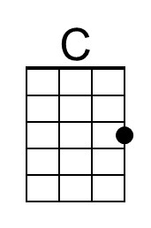 |  | 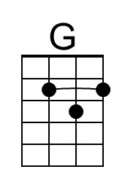
 |  |  |  |  |  |  | 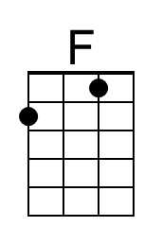 | 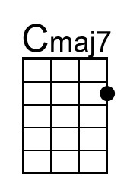
 |  |  |  |  |  |  | 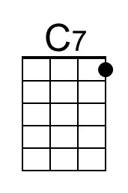 | 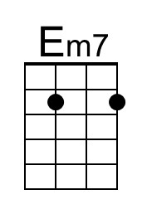
 |  |  |  |  |  |  | 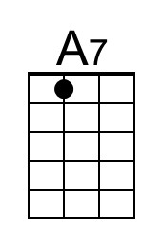 | 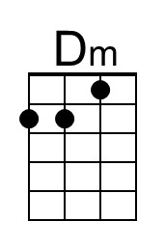
 |  |  |  |  |  |  | 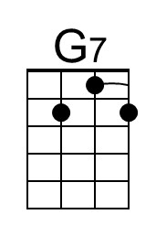 | 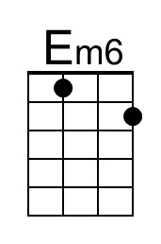
 |  | Bari | 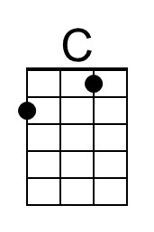 | 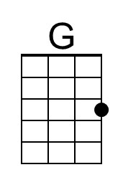 | 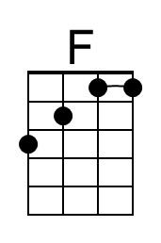 | 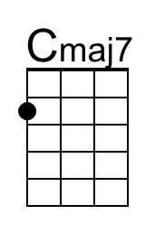 |  | 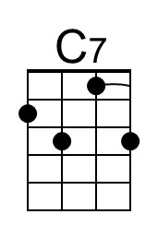
As of  June 3, 2021 |  |  | 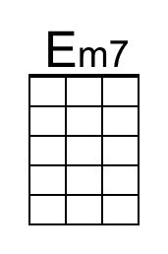 | 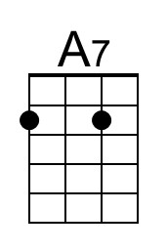 | 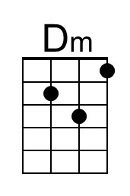 | 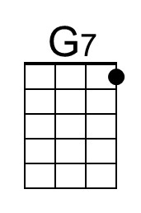 |  | 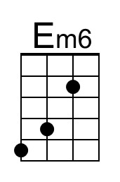

Raindrops Keep Falling On My Head (Burt Bacharach & Hal David, 1969) (G)
Raindrops Keep Falling On My Head by B. J. Thomas

Intro (4 Measures) | G D | C D | (2x) (Pattern: ↓_↓↑↓↑ ↓_↓↑↓↑ )  G Gmaj7  Raindrops keep falling on my head  G7 C Bm7  And just like the guy whose feet are too big for his bed  E7 Bm7 E7 Am D7  Nothing seems to fit - those raindrops are falling on my head  TACET G Gmaj7  They keep falling - so I just did me some talking to the sun  G7 C Bm7  And I said I didn't like the way he got things done  E7 Bm7 E7 Am D7  Sleeping on the job - those raindrops are falling on my head  D7  They keep falling – (PAUSE – Palm Mute or Hold)  Reprise  TACET G Bm7  But there's one thing _ I know,  C D7 Bm7  The blues they send to meet me won't de-feat me  Bm6 Am D7 | C C D _ | (2x)  It won't be long till happiness steps up to greet me  G Gmaj7  Raindrops keep falling on my head.  G7 C Bm7  But that doesn't mean my eyes will soon be turning red  E7 Bm7 E7 Am D7  Crying's not for me cause I'm never gonna stop the rain by complaining  G C D7 G  Because I'm free - nothing’s worrying me.  Repeat Reprise (Instrumental - kazoos?); join Reprise at “thing;” Sing and extend last line of Reprise. Last verse - extend last line. |  |  |  |  |  |  |  |  | 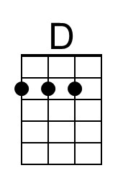
 |  |  |  |  |  |  |  | 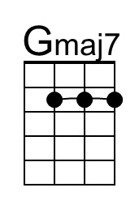
 |  |  |  |  |  |  |  | 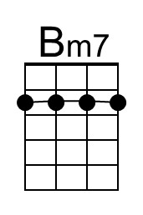
 |  |  |  |  |  |  | 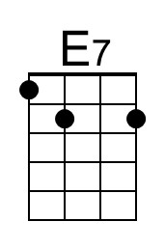 | 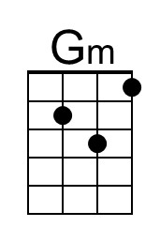
 |  |  |  |  |  |  | 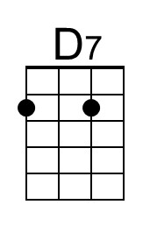 | 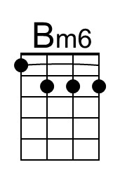
 |  | Bari |  | 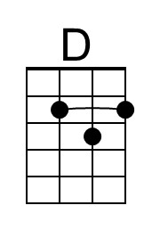 |  | 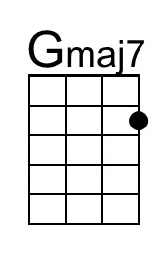
As of  June 3, 2021 |  |  | 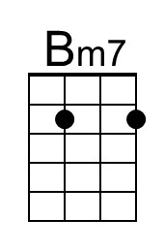 | 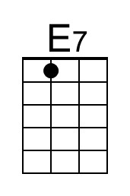 | 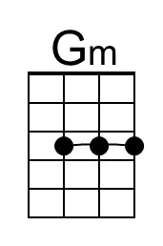 | 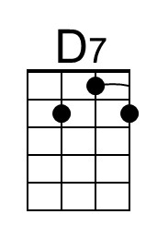 |  | 