Red Roses for a Blue Lady (Sid Tepper / Roy C. Bennett)

C G7 C B7
I - want - some red roses for a blue lady
E7 A7
Mister florist take my order please
Dm G7 Em Am
We had a silly quarrel the oth-er day
D7 G7
I hope these pretty flowers chase her blues away

C G7 C B7
Wrap up some red roses for a blue lady
E7 A7
Send them to the sweetest gal in town
Dm Em B
And if they do the trick I'll hurry back to pick
Dm G7 C
Your best white orchid for her wedding gown


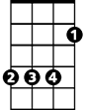


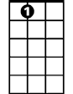
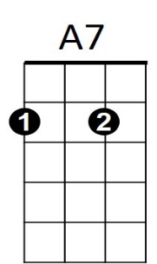
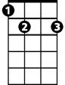


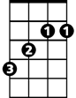
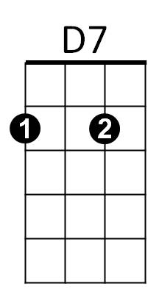
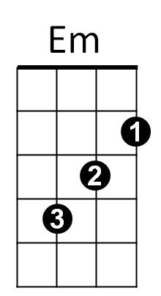


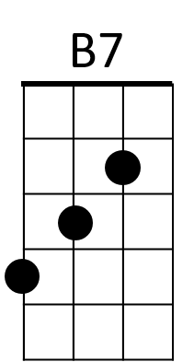
REPEAT ENTIRE SONG
Dm
B
D7
Em
E7
B7
G7
C
BARITONE
B
A7
Dm
E7
C
G7

