Rhythm of the Rain (John C. Gummoe, 1962) Key C
Intro: C Am C G7

C F
Listen to the rhythm of the falling rain
C G7
Telling me just what a fool I've been
C F
I wish that it would go and let me cry in vain
C G7 C G7
And let me be alone again

C F
The only girl I care about has gone away
C G7
Looking for a brand new start
C
But little does she know
F
That when she left that day
C G7 C C7
Along with her she took my heart

F Em
Rain please tell me now does that seem fair
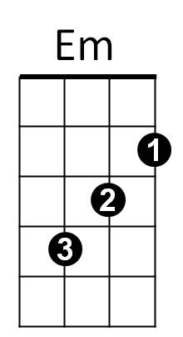





F
Am
C7
G7
F
C
For her to steal my heart away
C
When she don't care
Am F
I can't love another when my heart's
G7 C G7
Somewhere far away

C F
The only girl I care about has gone away
C G7
Looking for a brand new start
C
But little does she know
F
That when she left that day
C G7 C G7
Along with her she took my heart

(Instrumental Second Verse)

F Em
Rain won’t you tell her that I love her so
F C
Please ask the sun to set her heart aglow
Am F G7
Rain in her heart and let the love we knew
C G7
Start to grow.

(First Verse )

Outro: (repeat to fade)
C F
Oh listen to the falling rain,
C G7
Pitter patter, pitter patter, oh oh oh.
C F
Listen, listen to the falling rain,
C G7
Pitter patter, pitter patter, oh oh oh.

BARITONE

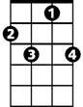

Am
C7
G7
Em
F
C

Rhythm of the Rain (John C. Gummoe, 1962) Key G
Intro: G Em G D7

G C
Listen to the rhythm of the falling rain
G D7
Telling me just what a fool I've been
G C
I wish that it would go and let me cry in vain
G D7 G D7
And let me be alone again

G C
The only girl I care about has gone away
G D7
Looking for a brand new start
G
Little does she know
C
That when she left that day
G D7 G G7
Along with her she took my heart

C Bm
Rain please tell me now does that seem fair
C
For her to steal my heart away
G
When she don't care
Em C
I can't love another when my heart's
D7 G D7
Somewhere far away

G C
The only girl I care about has gone away
Em
G D7
Looking for a brand new start
G
Little does she know
C
That when she left that day
G D7 G G7
Along with her she took my heart

(Instrumental Second Verse)

C Bm
Rain won’t you tell her that I love her so
C G
Please ask the sun to set her heart aglow
Em C D7
Rain in her heart and let the love we knew
G D7
Start to grow.

(First Verse)

Outro: (repeat to fade)
G C
Oh listen to the falling rain,
G D7
Pitter patter, pitter patter, oh oh oh.
G C
Listen, listen to the falling rain,
G D7
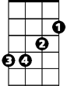
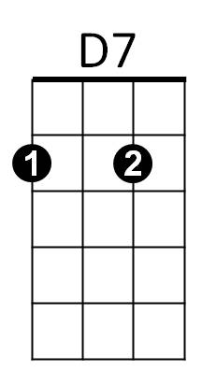
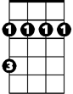

Pitter patter, pitter patter, oh oh oh.
BARITONE
D7
C
G7
G
Bm
Bm
G7
C
Em
G

