Ring of Fire (June Carter & Merle Kilgore)
INTRO: G C G / G D7 G

G C G (G C G)
Love is a burning thing
D7 G (G D7 G)
And it makes a fiery ring
C G (G C G)
Bound by wild desire
D7 G
I fell into a ring of fire

CHORUS:
D7 C G
I fell into a burning ring of fire
D7
I went down, down, down
C G
And the flames went higher
D7
And it burns, burns, burns
G D7
The ring of fire
G
The ring of fire

(INTRO 2X)

(CHORUS)

G C G (G C G)
The taste of love is sweet
D7 G (G D7 G)
When hearts like ours meet
C G (G C G)
I fell for you like a child
D7 G
Oh, but the fire went wild
(CHORUS 2X)

Ending:

G D7
And it burns, burns, burns
G D7
The ring of fire
G
The ring of fire

(INTRO 2X)



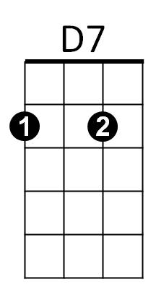

BARITONE
D7
C
G
C
G

