Ripple (Robert Hunter & Jerry Garcia, 1970)
Ripple by the Grateful Dead (2015 Remaster)
Ripple by the Grateful Dead (Official Music Video)
Tempo: 127 bpm
Intro  Instrumental verse (sing with “La-la-la”)  G C  If my words did glow with the gold of sunshine,  G  And my tunes were played on the harp unstrung  Would you hear my voice  C  Come through the music?  G D C G  Would you hold it near, as it were your own?  G C  It's a hand-me-down, the thoughts are broken.  G  Perhaps they're better left un-sung.  C  I don't know, don't really ca-re.  G D C G | G  Let there be songs to fill the air .  Chorus  Am D  Ri - pple in still water,  G C  When there is no pebble tossed,  A7 D  Nor wind to blow. |  |  |  | G C  Reach out your hand if your cup be empty.  G  If your cup is full, may it be a-gain.  C  Let it be known, there is a fountain,  G D C G  That was not made by the hands of man.  G C  There is a road, no simple highway,  G  Between the dawn and the dark of night.  C  And if you go, no one may follow,  G D C G | G  That path is for your steps a-lone. Chorus  G C  You who choose to lead must follow  G  But if you fall, you fall a-lone.  C  If you should stand, then who's to guide you?  G D C G  If I knew the way, I would take you home.  Outro  Instrumental verse (sing “la-la-la” along)  End on G [Hold]
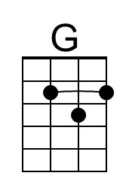 | 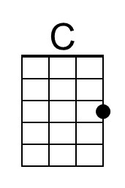 | 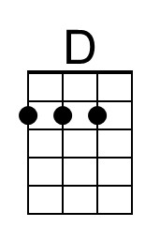 |  | Bari | 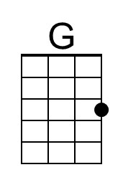 | 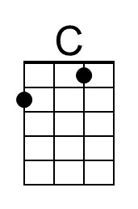 | 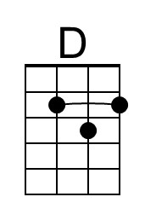
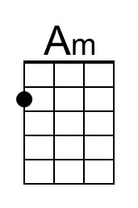 | 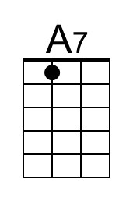 |  |  |  | 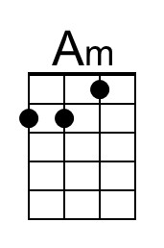 | 