River (Bill Staines, circa 1979) (E)
River by Bill Staines from "The Whistle of the Jay" (E)
¾ Time – Tempo 150 bpm

Intro E | A | E | A

E A E
I was born in the path of the winter wind.
B7
I was raised where the mountains are old.
E A E B7 E | E
Their springtime waters came dancing down, and I remember the tales they told.

E A E
The whistling ways of my younger days
B7
Too quickly have faded on by.
E A E B7 E | E
But all of their memories linger on, like the light in a fading sky.

Chorus
E A B7 E A B7
River, take me a-long in your sun-shine, sing me your song.
A E
Ever moving and winding and free.
A E A E
You rolling old river, you changing old river,
A B7 A E | E | E | E
Let's you and me, river, run down to the sea.

E A E
I've been to the city and back again.
B7
I've been moved by some things that I've learned.
E A E
Met a lot of good people an’ I called them friends,
B7 E | E
Felt the change when the seasons turned.

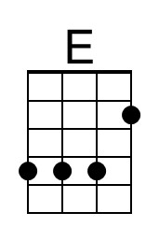 | 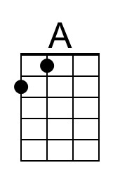 | 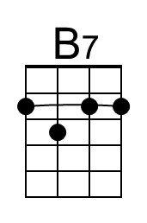 |  | Bari | 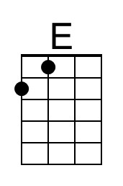 | 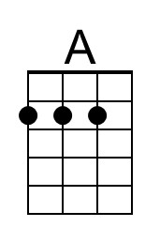 | 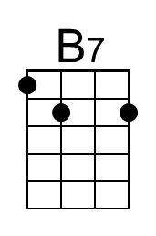
River (E) – Page 2
E A E
I've heard all the songs that the children sing
B7
And listened to love's melo-dies.
E A E B7 E | E
I've felt my own music within me rise, like the wind in the autumn trees.

Chorus
E A B7 E A B7
River, take me a-long in your sun-shine, sing me your song.
A E
Ever moving and winding and free.
A E A E
You rolling old river, you changing old river,
A B7 A E | E | E | E
Let's you and me, river, run down to the sea.

E A E
Some-day when the flowers are blooming still,
B7
Someday when the grass is still green,
E A E B7 E | E
My rolling waters will round the bend, flow into the open sea.

E A E
So, here's to the rainbow that's followed me here.
B7
And here's to the friends that I know.
E A E B7 | E
And here's to the song that's within me now, I will sing it wher-e’er I go. Chorus

Outro
E A B7 E A B7
River, take me a-long in your sun-shine, sing me your song.
A E A E A E
Ever moving and winding and free. You rolling old river, you changing old river
A B7 | B7
Let's you and me, river,
B7 A B7 A E | E | A | B7 | D
Run down to the sea. [Hold]

