River (Bill Staines) Key C

C F C
I was born in the path of the winter wind
G7
I was raised where the mountains are old
C F C
Their springtime waters came dancing down
G7 C
And I remember the tales they told

C F C
The whistling ways of my younger days
G7
Too quickly have faded on by
C F C
But all of their memories linger on
G7 C
Like the light in a fading sky

Chorus:

C F G7 C
Ri-ver, take me along in your sun-shine,
F G7
sing me your song
F C
Ever mo-ving and winding and free
F C F C
You rolling old river, you changing old river
F G7 F C
Let's you and me, river, run down to the sea

C F C
I've been to the city and back again
G7
I've been moved by some things that I've learned
C F
Met a lot of good people and I've called them
C
friends
G7 C
Felt the change when the seasons turned

C F C
I've heard all the songs that the children sing
G7
And listened to love's melodies
C F C
I've felt my own music within me rise
G7 C
Like the wind in the autumn trees
(Chorus)

C F C
Someday when the flowers are blooming still
G7
Someday when the grass is still green
C F C
My rolling waters will round the bend
G7 C
And flow into the open sea

C F C
So, here's to the rainbow that's followed me here
G7
And here's to the friends that I know
C F C
And here's to the song that's within me now
G7 C
I will sing it wherever I go

(Chorus) 2x




C
F
G7

BARITONE


G7
F
C

River (Bill Staines) Key G

G C G
I was born in the path of the winter wind
D7
I was raised where the mountains are old
G C G
Their springtime waters came dancing down
D7 G
And I remember the tales they told

G C G
The whistling ways of my younger days
D7
Too quickly have faded on by
G C G
But all of their memories linger on
D 7 G
Like the light in a fading sky

Chorus:

G C D7 G
Ri-ver, take me along in your sun-shine,
C D7
sing me your song
C G
Ever mo-ving and winding and free
C G C G
You rolling old river, you changing old river
C D7 C G
Let's you and me, river, run down to the sea

G C G
I've been to the city and back again
D7
I've been moved by some things that I've learned
G C
Met a lot of good people and I've called them
G
friends
D7 G
Felt the change when the seasons turned

G C G
I've heard all the songs that the children sing
D7
And listened to love's melodies
G C G
I've felt my own music within me rise
D7 G
Like the wind in the autumn trees
(Chorus)

G C G
Someday when the flowers are blooming still
D7
Someday when the grass is still green
G C G
My rolling waters will round the bend
D7 G
And flow into the open sea

G C G
So, here's to the rainbow that's followed me here
D7
And here's to the friends that I know
G C G
And here's to the song that's within me now
D7 G
I will sing it wherever I go

(Chorus) 2x


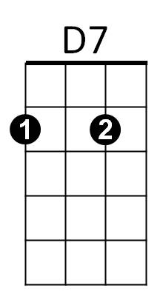
G
C

BARITONE
C
D7
G

River (Bill Staines) Key D

D G D
I was born in the path of the winter wind
A7
I was raised where the mountains are old
D G D
Their springtime waters came dancing down
A7 D
And I remember the tales they told

D G D
The whistling ways of my younger days
A7
Too quickly have faded on by
D G D
But all of their memories linger on
A7 D
Like the light in a fading sky

Chorus:

D G A7 D
Ri-ver, take me along in your sun-shine,
G A7
sing me your song
G D
Ever mo-ving and winding and free
G D G D
You rolling old river, you changing old river
G A7 G D
Let's you and me, river, run down to the sea

D G D
I've been to the city and back again
A7
I've been moved by some things that I've learned
D G
Met a lot of good people and I've called them
D
friends
A7 D
Felt the change when the seasons turned

D G D
I've heard all the songs that the children sing
A7
And listened to love's melodies
D G D
I've felt my own music within me rise
A7 D
Like the wind in the autumn trees
(Chorus)

D G D
Someday when the flowers are blooming still
A7
Someday when the grass is still green
D G D
My rolling waters will round the bend
A7 D
And flow into the open sea

D G D
So, here's to the rainbow that's followed me here
A7
And here's to the friends that I know
D G D
And here's to the song that's within me now
A7 D
I will sing it wherever I go

(Chorus) 2x


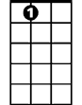
G
D
A7

BARITONE

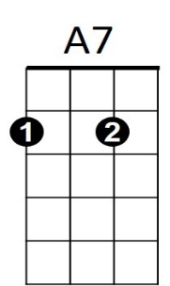
D
G

