Rocking Around the Christmas Tree (Johnny Marks)
C26
Intro (Four Measures): C | Am | F | G7 |




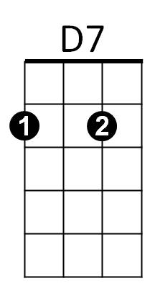
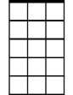


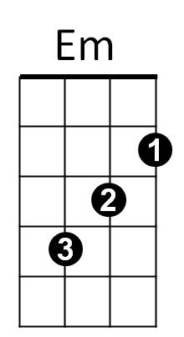
C
F
Dm
C7
Am7
G7
Am
C
Rocking around the Christmas tree
G7
At the Christmas party hop
Dm G7 Dm G7
Mistletoe hung where you can see
Dm C
Every couple tries to stop

C
Rocking around the Christmas tree
G7
Let the Christmas spirit ring
Dm G7 Dm G7
Later we'll have some pumpkin pie
Dm C C7
And we'll do some carol-ing

Bridge:
BARITONE

F
Am
C
F Em
You will get a sentimental feeling when you hear
Am Am7
Voices singing, "Let's be jolly
D7 G7
Deck - the halls with boughs of holly!"
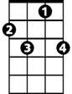

C7
Dm
G7
C
Rocking around the Christmas tree
G7
Have a happy holiday
Dm G7 Dm G7
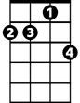
Everyone dancing merri-ly
D7
Em
Am7
F G7 C
In the new old-fashioned way! Repeat from Bridge

Outro
G7 F G7 C C F G7 C
In the new – old – fash - ioned - way!

