Run To Me (Barry, Robin & Maurice Gibbs)
C Bb
If ev er you got rain in your heart,
Am F Am Dm
Someone has hurt you, and torn you apart,
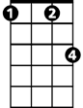
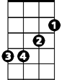
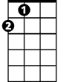






G C
Fm
Em
A
Dm
F
G
Am
C
Bb
Am I unwise to open up your eyes to love me?

C Bb
And let it be like they said it would be -
Am F Am Dm
Me loving you girl, and you loving me.
G C
Am I unwise to open up your eyes to love me?

Chorus:
C Em
Run to me whenever you're lonely
F Fm
Run to me if you need a shoulder
C Bb A
Now and then, you need someone older,
Fm G C

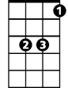
So darling, you run to me.
Em
Dm
G
C
Am
Bb
BARITONE

C Bb
And when you're out in the cold,
Am F Am Dm
No one beside you, and no one to hold,
G C
F
Am I unwise to open up your eyes to love me?

C Bb
And when you've got nothing to lose,
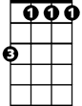

Am F Am Dm
Fm
A
Nothing to pay for, nothing to choose,
G C
Am I unwise to open up your eyes to love me?

(Chorus) (2X)

