Santa Baby (Joan Javits, Philip Springer and Tony Springer)

Intro: C A7 D7 G7
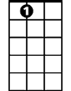
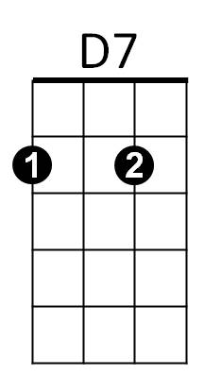

A7
C
C A7 D7 G7 C
Santa Baby, slip a sable under the tree -
A7 D7 G7 C
- For me. I've been an awful good girl.
A7 D7 G7 C A7 D7 G7
Santa baby so hurry down the chimney tonight.

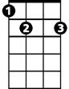

G
E7
G7
C A7 D7 G7 C A7
Santa Baby, a 54 convertable too, light blue.
D7 G7 C
Well I'll wait up for you dear.
A7 D7 G7 C A7 D7 G7
Santa Baby so hurry down the chimney tonight.

E7
Think of all the fun I've missed.
A7
Think of all the boys I haven't kissed.
D7
Next year I could be just as good
G7 G
If you’ll check off my Christmas list.

C A7 D7 G7 C A7
Santa Baby, I want a yacht and really that’s not - a lot.
D7 G7 C
I've been an angel all year.
C A7 D7 G7 C A7 D7 G7
Santa Baby, so hurry down the chimney tonight.
BARITONE

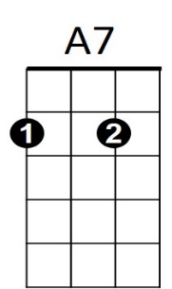

C A7 D7 G7 C
G
E7
G7
C
D7
Santa Honey, there’s one more thing I really do need.~
A7 D7 G7 C
- The deed - to a platinum mine.
A7 D7 G7 C A7 D7 G7
Santa Honey, so hurry down the chimney tonight.

E7
Come and trim my Christmas tree
A7
With some decorations bought from Tiffany’s
D7 G7 G
I really do believe in you, let’s see if you believe in me.

C A7 D7 G C A7
Santa Baby, forgot to mention one little thing - A RING,
D7 G7 C
- And I don’t mean on the phone.
A7 D7 G7 C A7
Santa Baby, So hurry down the chimney tonight.
D7 G7 C A7 (x4)
So hurry down the chimney tonight.

