Santa Claus Is Coming to Town
(J. Fred Coots / Henry Gillespie, 1934)
C16
Chorus:
C F
You'd better watch out, you'd better not cry



C F
Am
F
C
You'd better not pout, I'm telling you why
C Am F G7 C G7
Santa Claus is coming to town [End on C]
C F
He's making a list, he's checkin' it twice

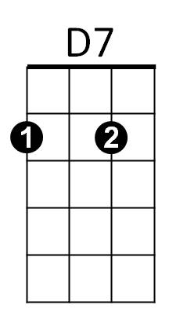

C F
G7
C7
He's gonna find out who's naughty and nice
C Am F G7 C
Santa Claus is coming to town
Reprise:
C7 F
He sees you when you're sleeping,
C7 F
He knows if you're awake,
D7 G7
He knows if you've been bad or good
D7 G7
So be good for goodness sake
(Chorus)
C F
With little tin horns and little toy drums
C F
Rooty toot toots and rum-a tum tums
C Am F G7 C
Santa Claus is coming to town
BARITONE


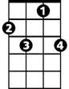
C
F
Am
D7
C7
G7
C F
With curly haired dolls that cuddle and coo
C F
Elephants, boats and kiddie cars, too
C Am F G7 C
Santa Claus is coming to town

C7 F
The kids in girls and boy-land
C7 F
Will have a jubilee
D7 G7
They’re gonna build a toyland town
D7 G7
All around the Christmas tree (Chorus / Reprise / Chorus)

