Save The Last Dance For Me Key of C
Doc Pomus and Mort Shuman
Intro: Chords for Chorus

C G
You can dance, every dance with the guy who gives you the eye, let him hold you tight
C
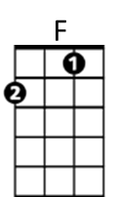
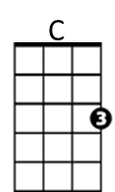
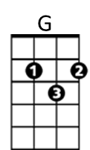
You can smile ~ every smile for the man who held your hand 'neath the pale moonlight,

But -

Chorus:

F C
Don't forget who's taking you home and in whose arms you're gonna be ~~
G C
So darling, save the last dance for me

C G
Oh I know ~ that the music's fine like sparkling wine, Go and have your fun
C
Laugh and sing ~ but while we're apart, Don't give your heart to anyone, and -

(CHORUS)

C G C
Baby don't you know I love you so - Can't you feel it when we touch
G C
I will never never let you go - Cause I love you oh so much

C G
You can dance ~ go and carry on, till the night is gone and it's time to go
C
If he asks ~ if you're all alone can he take you home, you must tell him no, and

(CHORUS)




ending:
G
C
F
BARITONE
G C
So darling, save the last dance for me ( 2x)

