Scales – Do, Re, Mi, Fa, So, La, Ti, Do

F Y I:
Do | Re | Mi | Fa | So | La | Ti | Do
1 | 2 | 3 | 4 | 5 | 6 | 7 | 8 [ 1² ]

Ascending | Descending
Do, Re, Mi, Re, Do  Re, Mi, Fa, Mi, Re  Mi, Fa, So, Fa, Mi  Fa, So, La, So, Fa  So, La, Ti, La, So  La, Ti, Do, Ti, Do | La, Ti, Do, Ti, Do  So, La, Ti, La, So  Fa, So, La, So, Fa  Mi, Fa, So, Fa, Mi  Re, Mi, Fa, Mi, Re  Do, Re, Mi, Re, Do

Ascending | Descending
Do, Re, Mi, Fa, So, La, Ti, Do. | Do, Ti, La, So, Fa, Mi, Re, Do.

Intervals

1 – 3 | 3 - 5 | 2 - 4 | 6 - 7
Do, Mi, Mi. | Mi, So, So. | Re, Fa, Fa. | La, Ti, Ti
Do, Mi, Mi. | Mi, So, So. | Re, Fa, Fa. | La, Ti, Ti

Each Note for One Beat: | Intervals:
So, Do, La, Fa, Mi, Do, Re | 5 1 6 4 3 1 2
So, Do, La, Fa, Mi, Do, Re | 5 1 6 4 3 1 2
So, Do, La, Te, Do, Re, Do | 5 1 6 4 1² 2² 1²
So, Do, La, Te, Do, Re, Do | 5 1 6 4 1² 2² 1²

Each Note for Two Beats: | Intervals:
So, Do, La, Fa, Mi, Do, Re | 5 1 6 4 3 1 2
So, Do, La, Fa, Mi, Do, Re | 5 1 6 4 3 1 2
So, Do, La, Te, Do, Re, Do | 5 1 6 4 1² 2² 1²
So, Do, La, Te, Do, Re, Do | 5 1 6 4 1² 2² 1²

Do-Re-Mi from “The Sound of Music” (C)
(Richard Rodgers & Oscar Hammerstein II, 1959) – Do-Re-Mi by Julie Andrews
2/2 Time – Tempo  = 72
Intro (2 Measures) G  G  Let´s start at the very beginning.  G  A very good place to start.  G7 C  When you read you begin with A, B, C.  G7 C G C G C  When you sing you be-gin with do-re-mi.  C G C C  Do-re-mi? Do-re-mi.  G G7 C G7 C  The first three notes just happen to be:  C G C C  Do-re-mi! Do-re-mi!  C G7  Do-re-mi-fa-so-la-ti.  Refrain  C C  Doe, a deer, a female deer.  G7 G7  Ray, a drop of golden sun.  C C  Me, a name I call myself.  G9 G9  Far, a long long way to run.  C C7 F  Sew, a needle pulling thread.  D7 G  La, a note to follow sew.  E7 Am | C7  Tea, a drink with jam and bread.  ___________________________________________  │ F G7 C G  │ 1. That will bring us back to do - oh - oh - oh!  │ Repeat Refrain  ___________________________________________  │ F G7 C  │2. That will bring us back to do!  │ F G7 C  │ _ Do – re – mi – fa – so – la – ti – do. | 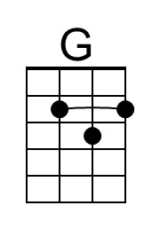 | 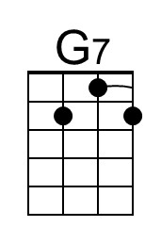 | 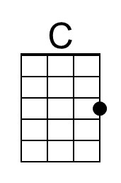
 | 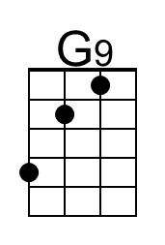 | 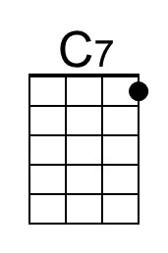 | 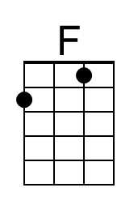
 | 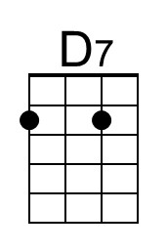 | 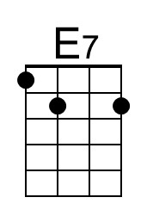 | 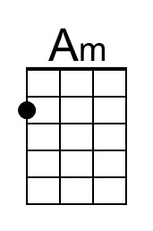
 | Bari
 | 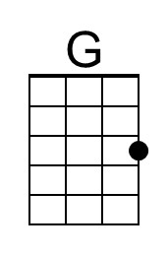 | 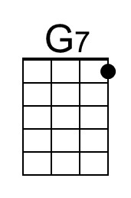 | 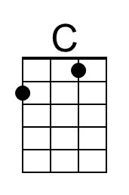
 | 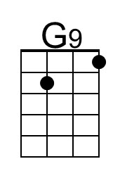 | 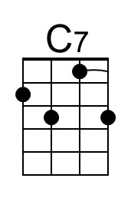 | 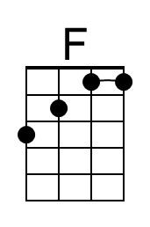
 | 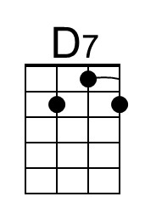 | 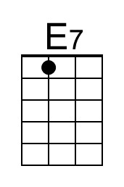 | 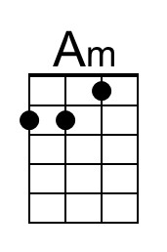

Do-Re-Mi from “The Sound of Music” (G)
Richard Rodgers & Oscar Hammerstein II, 1959 – Do-Re-Mi by Julie Andrews
2/2 Time – Tempo  = 72
Intro (2 measures) D  D  Let´s start at the very beginning.  D  A very good place to start.  D7 G  When you read you begin with A, B, C.  D7 G D G D G  When you sing you be-gin with do-re-mi.  G D G G  Do-re-mi? Do-re-mi.  D D7 G D7 G  The first three notes just happen to be:  G D G G  Do-re-mi! Do-re-mi!  G D7  Do-re-mi-fa-so-la-ti.  Refrain  G G  Doe, a deer, a female deer.  D7 D7  Ray, a drop of golden sun.  G G  Me, a name I call myself.  D9 D9  Far, a long long way to run.  G G7 C  Sew, a needle pulling thread.  A7 D  La, a note to follow sew.  B7 Em | G7  Tea, a drink with jam and bread.  ___________________________________________  │ C Am7 D7 G D  │ 1. That will bring us back to do - oh - oh - oh!  │ Repeat Refrain  ___________________________________________  │ Am7 D7 G  │ 2. That will bring us back to do!  │ F G7 C  │ _ Do – re – mi – fa – so – la – ti – do. So – do! | 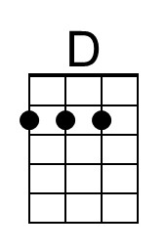
 | 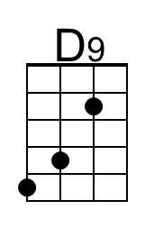 |  | 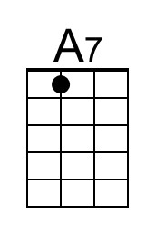
 | 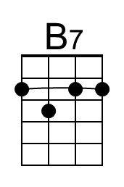 | 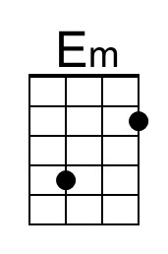 | 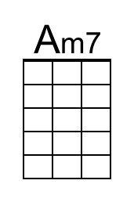
 | Bari
 | 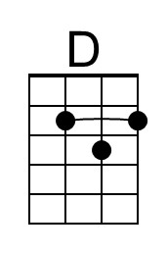
 | 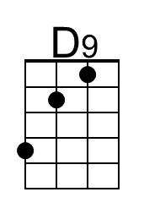 |  | 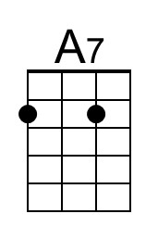
 | 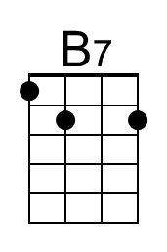 | 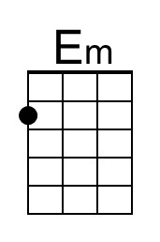 | 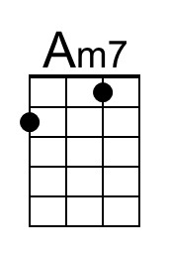

Do-Re-Mi from “The Sound of Music” (C)
(Richard Rodgers & Oscar Hammerstein II, 1959) – Do-Re-Mi by Julie Andrews
2/2 Time – Tempo  = 72
Intro (2 Measures) G

G G
Let´s start at the very beginning. A very good place to start.
G7 C
When you read you begin with A, B, C.
G7 C G C G C C G C C
When you sing you be-gin with do-re-mi. Do-re-mi? Do-re-mi.
G G7 C G7 C C G C C
The first three notes just happen to be: Do-re-mi! Do-re-mi!
C G7
Do-re-mi-fa-so-la-ti.

Refrain
C C
Doe, a deer, a female deer.
G7 G7
Ray, a drop of golden sun.
C C
Me, a name I call myself.
G9 G9
Far, a long long way to run.
C C7 F
Sew, a needle pulling thread.
D7 G
La, a note to follow sew.
E7 Am | C7
Tea, a drink with jam and bread.
___________________________________________
│ F G7 C G
│ 1. That will bring us back to do - oh - oh - oh!
│ Repeat Refrain

___________________________________________
│ F G7 C
│2. That will bring us back to do!
│ F G7 C
│ _ Do – re – mi – fa – so – la – ti – do. So – do!
Do-Re-Mi from “The Sound of Music” (G)
Richard Rodgers & Oscar Hammerstein II, 1959 – Do-Re-Mi by Julie Andrews
2/2 Time – Tempo  = 72
Intro (2 measures) D

D D
Let´s start at the very beginning. A very good place to start.
D7 G
When you read you begin with A, B, C.
D7 G D G D G G D G G
When you sing you be-gin with do-re-mi. Do-re-mi? Do-re-mi.
D D7 G D7 G G D G G
The first three notes just happen to be: Do-re-mi! Do-re-mi!
G D7
Do-re-mi-fa-so-la-ti.

Refrain
G G
Doe, a deer, a female deer.
D7 D9 D7
Ray, a drop of golden sun.
G G
Me, a name I call myself.
D9 D9
Far, a long long way to run.
G G7 C
Sew, a needle pulling thread.
A7 D
La, a note to follow sew.
B7 Em | G7
Tea, a drink with jam and bread.
___________________________________________
│ C Am7 D7 G D
│ 1. That will bring us back to do - oh - oh - oh!
│ Repeat Refrain

___________________________________________
│ Am7 D7 G
│ 2. That will bring us back to do!
│ F G7 C
│ _ Do – re – mi – fa – so – la – ti – do. So – do!

