Scotland the Brave (Marion McClurg / Cliff Hanley)



G
F
C
C
Hark when the night is falling, Hear! Hear! The pipes are calling,
F C G
Loudly and proudly calling, down thro' the glen.
C
There where the hills are sleeping, now feel the blood a-leaping,

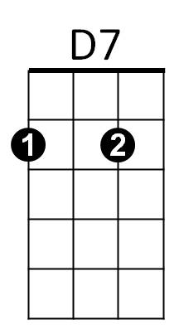

F C G C
G7
Am
High as the spirits of the old Highland men.

Chorus:

G C
Towering in gallant fame, Scotland my mountain hame,
Am D7 G G7
High may your proud standards gloriously wa ve!
C
Land of my high endeavour, land of the shining river,
F C G C
Land of my heart for ever, Scotland the Brave.

C
High in the misty Highlands out by the purple islands,
F C G G7
Brave are the hearts that beat beneath Scottish skies.
C
Wild are the winds to meet you, staunch are the friends that greet you,
F C G C
Kind as the love that shines from fair maidens' eyes.

(Chorus)
BARITONE

F
C
G
C
Far off in sunlit places, sad are the Scottish faces,
F C G
Yearning to feel the kiss of sweet Scottish rain.
C
Where are the tropics beaming, love sets the heart a-dreaming,
F C G C


Longing and dreaming for the hameland again.
Am
D7
G7

(Chorus)

F C G C
Land of my heart for ever, Scotland the Brave!

